**Assignment 1**:

Install python , pyCharm and plug-in AWS kit then configure AWS using IAM user in cmd.

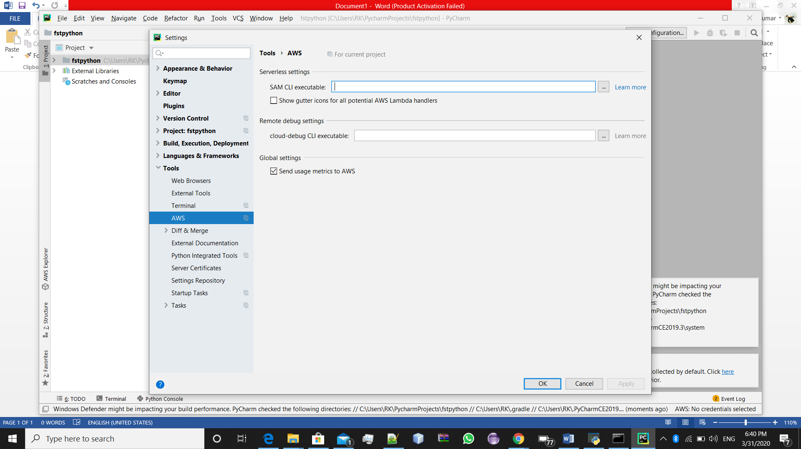

1.) AWS kit Installed in pycharm Screenshot

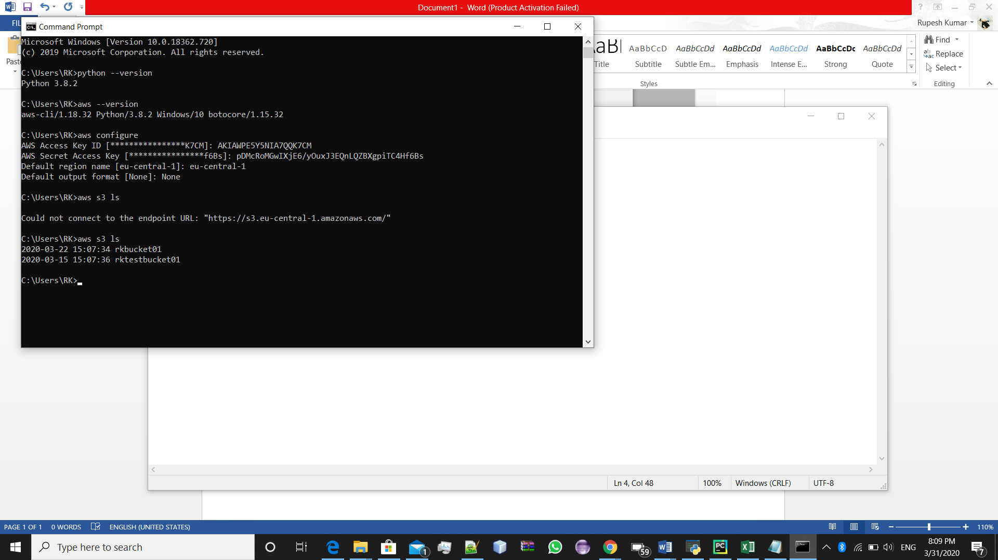

2.) AWS configure screenshot in cmd using IAM user

**Assignment 2** :

Create VPC with two instances, one in public subnet and one in private subnet. From EC2 instance in public subnet , connect with EC2 instance in private subnet. Then from private subnet EC2 instance ,upload a file to S3 bucket.

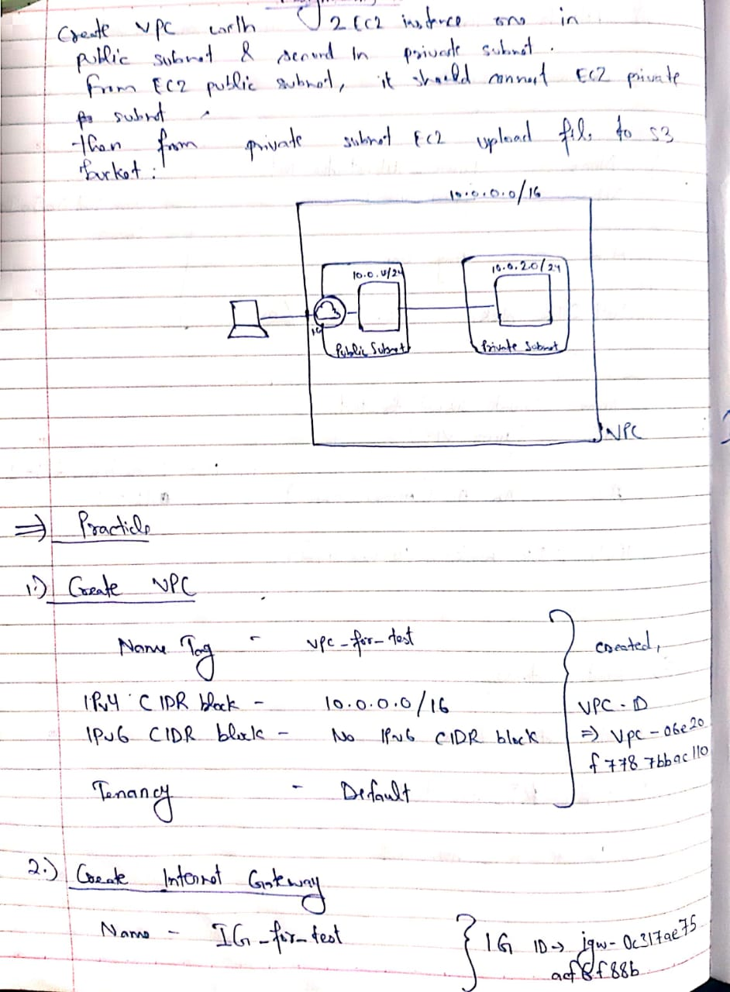

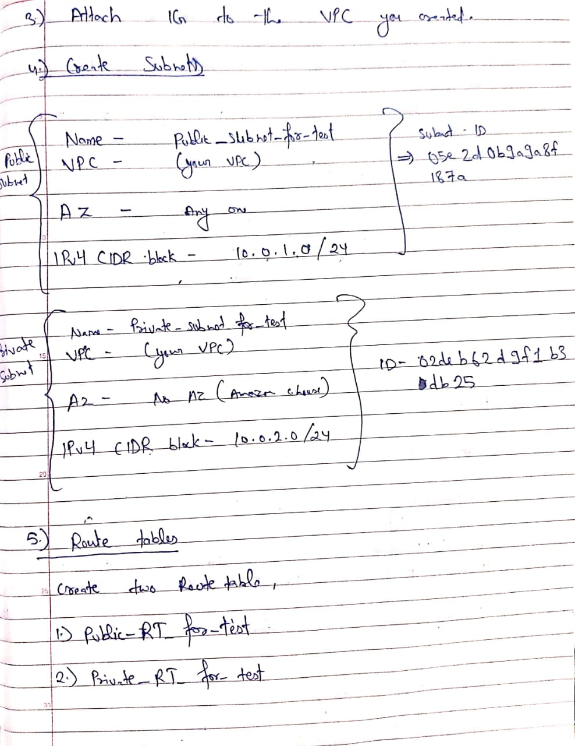

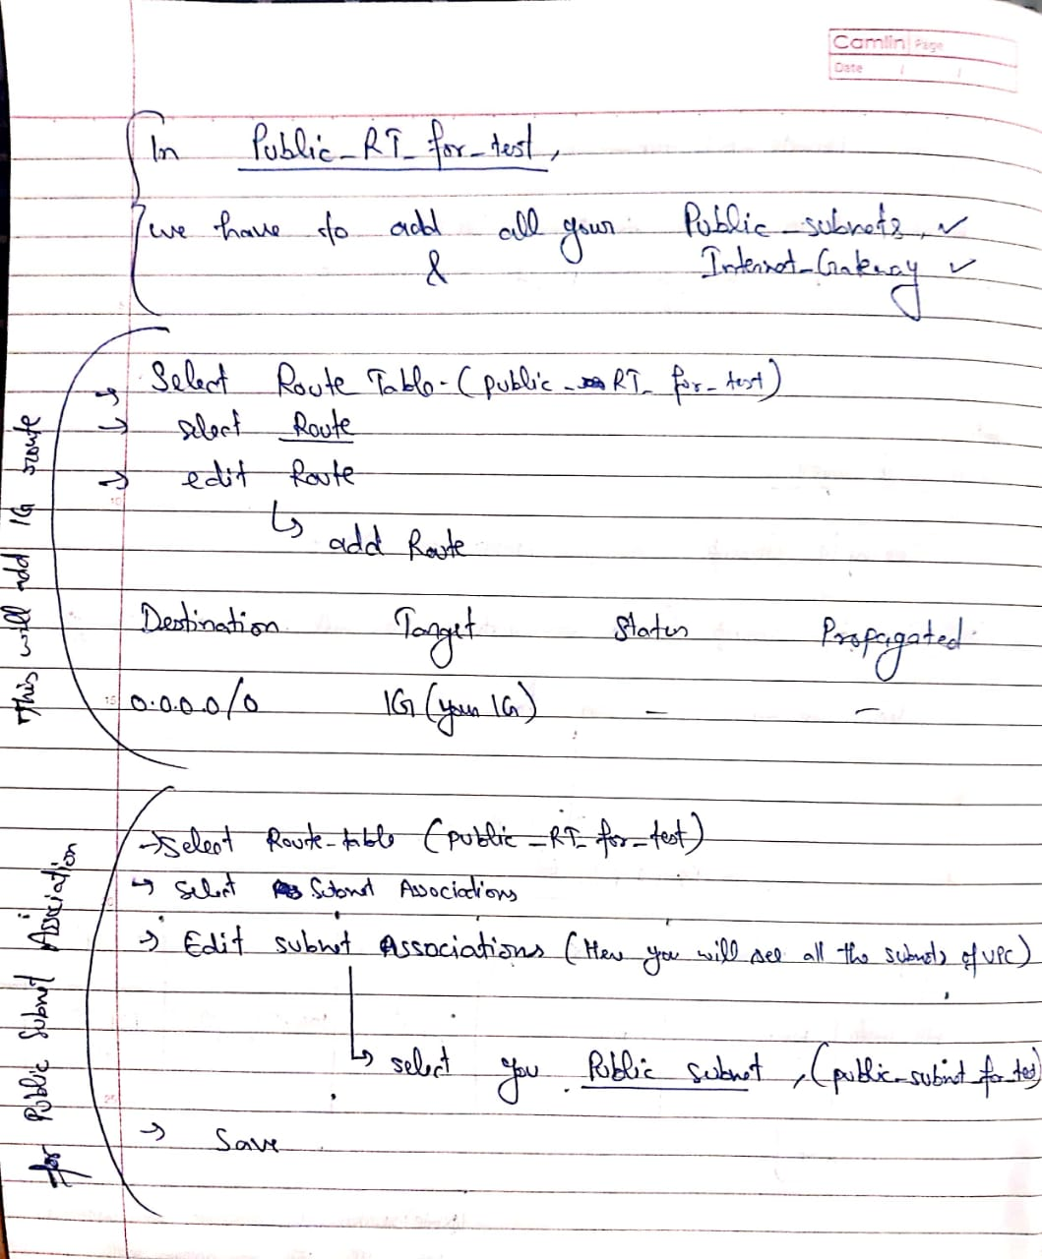

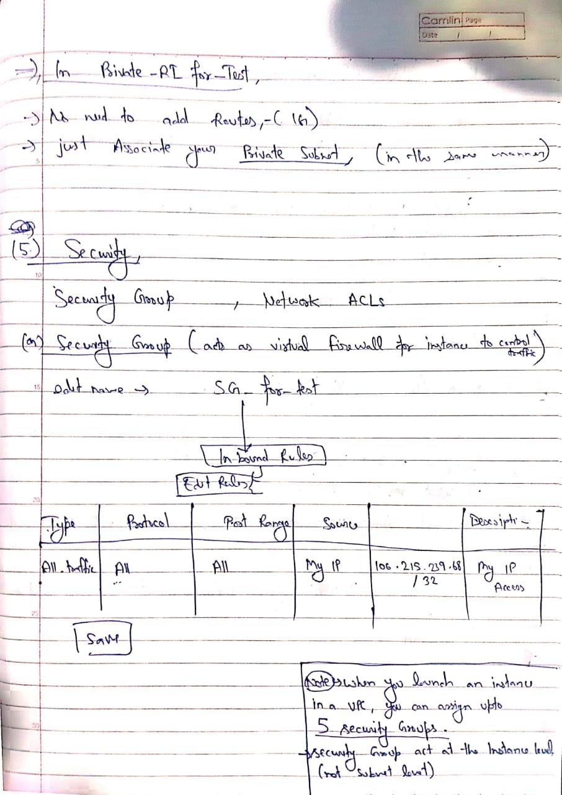

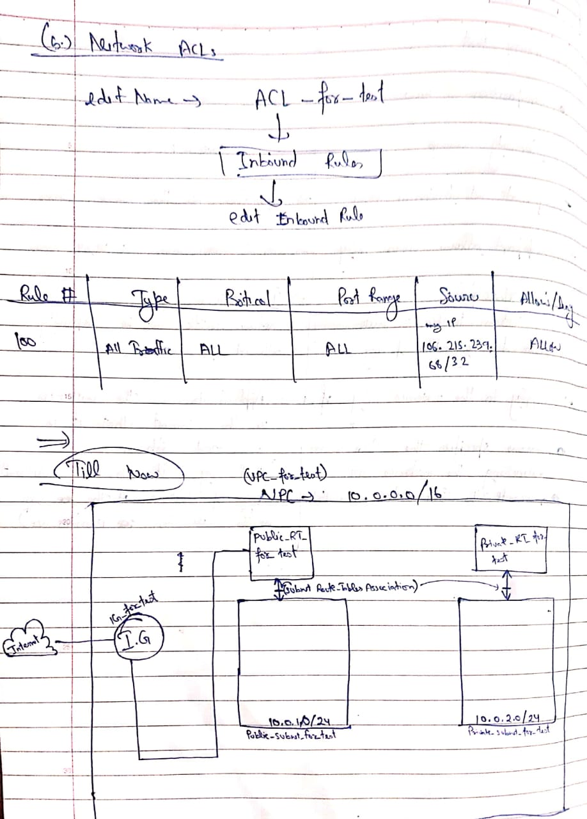

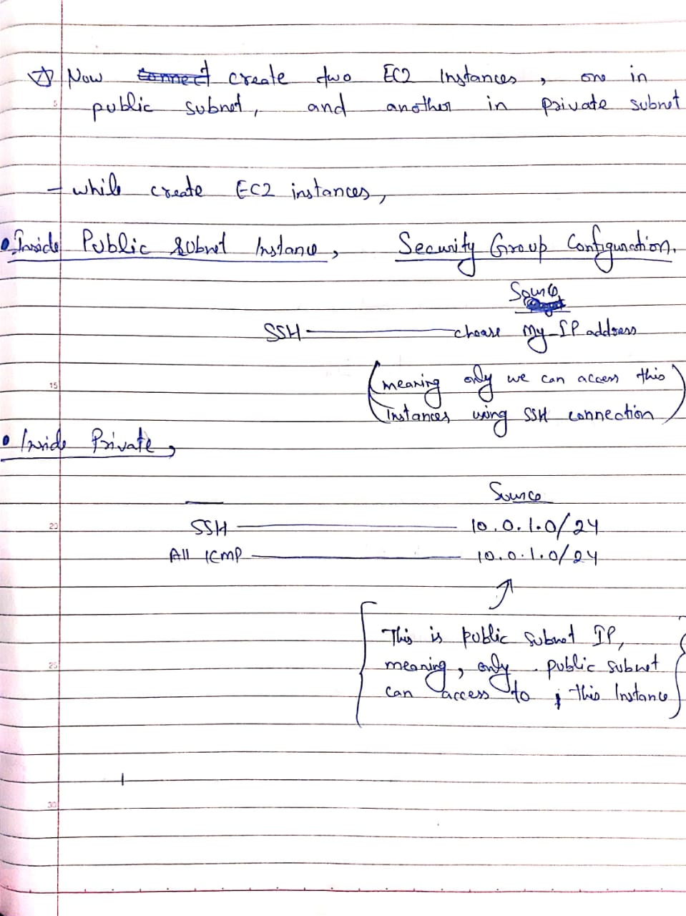

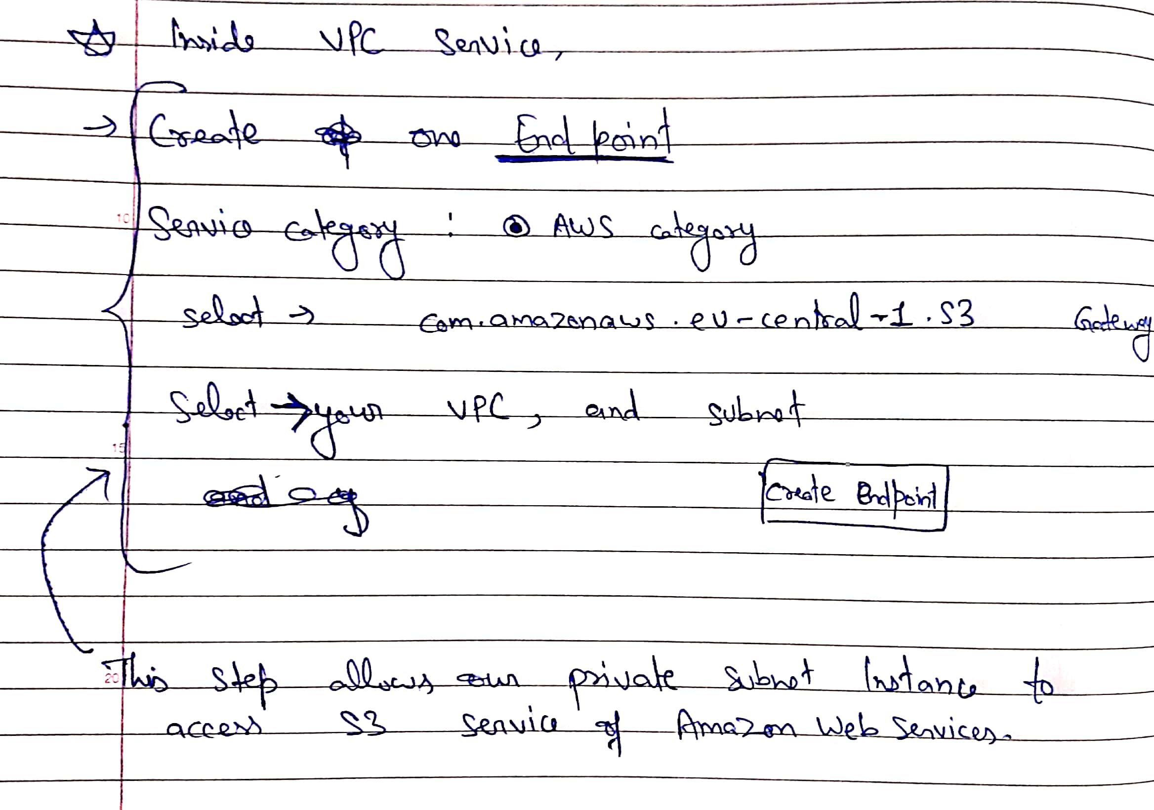

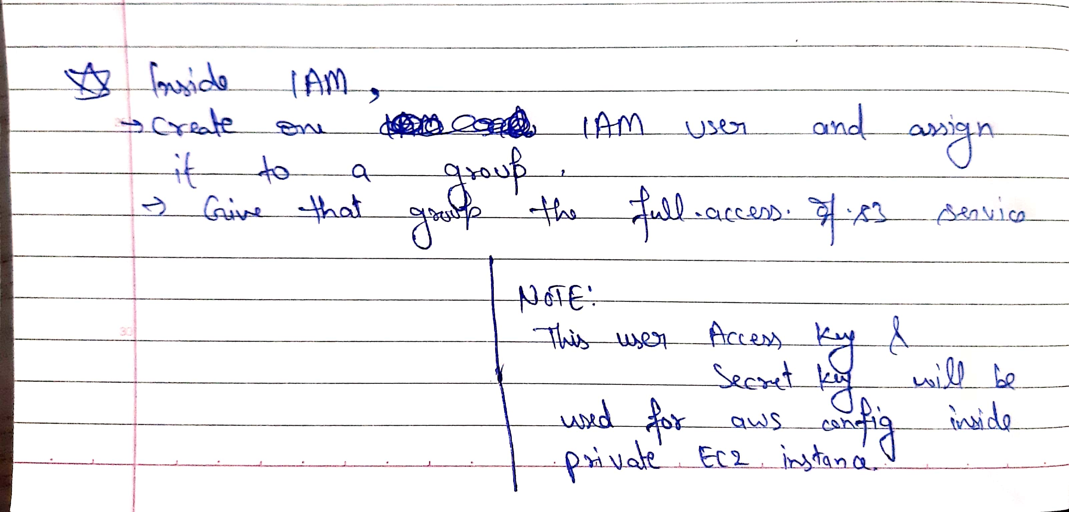

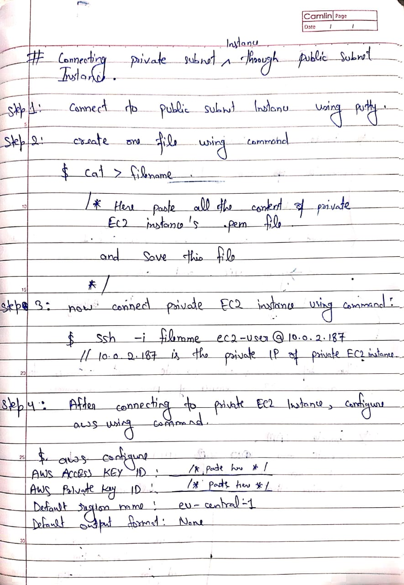

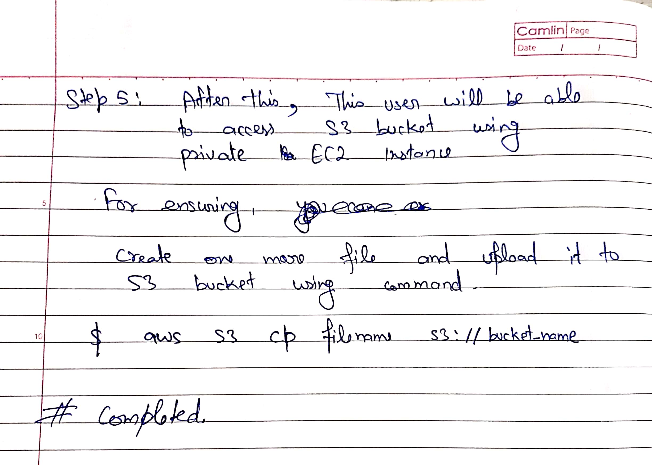

**Assignment 3** :

create a bucket policy to make the .jpg files accessible to all public users (without login). And restrict the .pdf files to the public users.

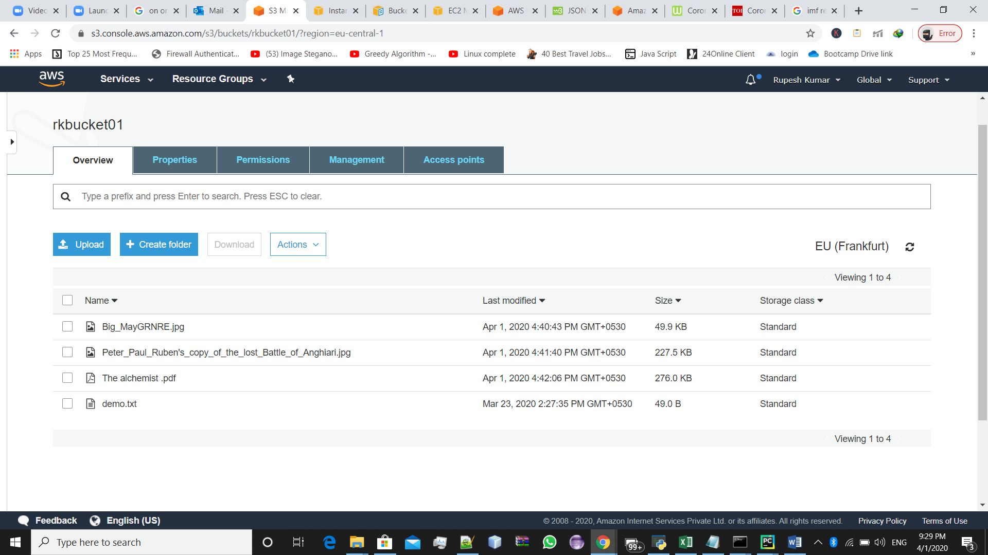

This is the bucket with some .pdf and .jpg files.

*Now, for blocking the public access for .pdf file and allow .png file to public users,

->First ,We will make the bucket accessable to all(public)

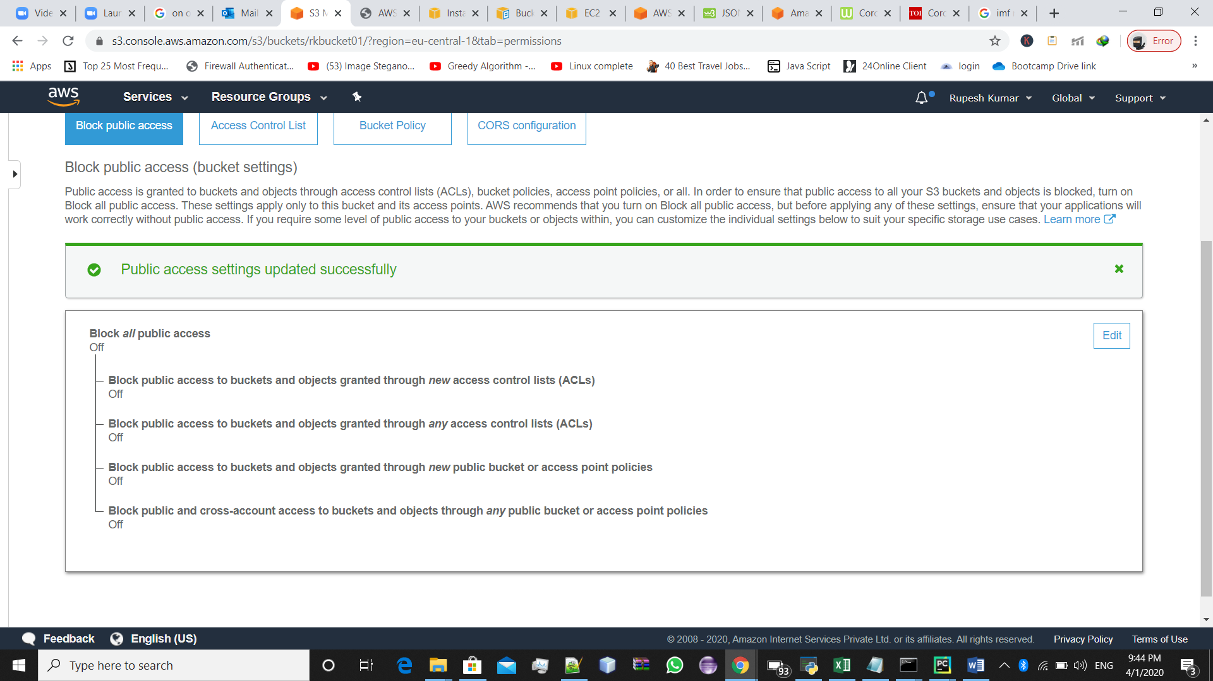

->Then, We will go to **Permissions** ->**Bucket Policy** create one new policy using **Policy Generator**

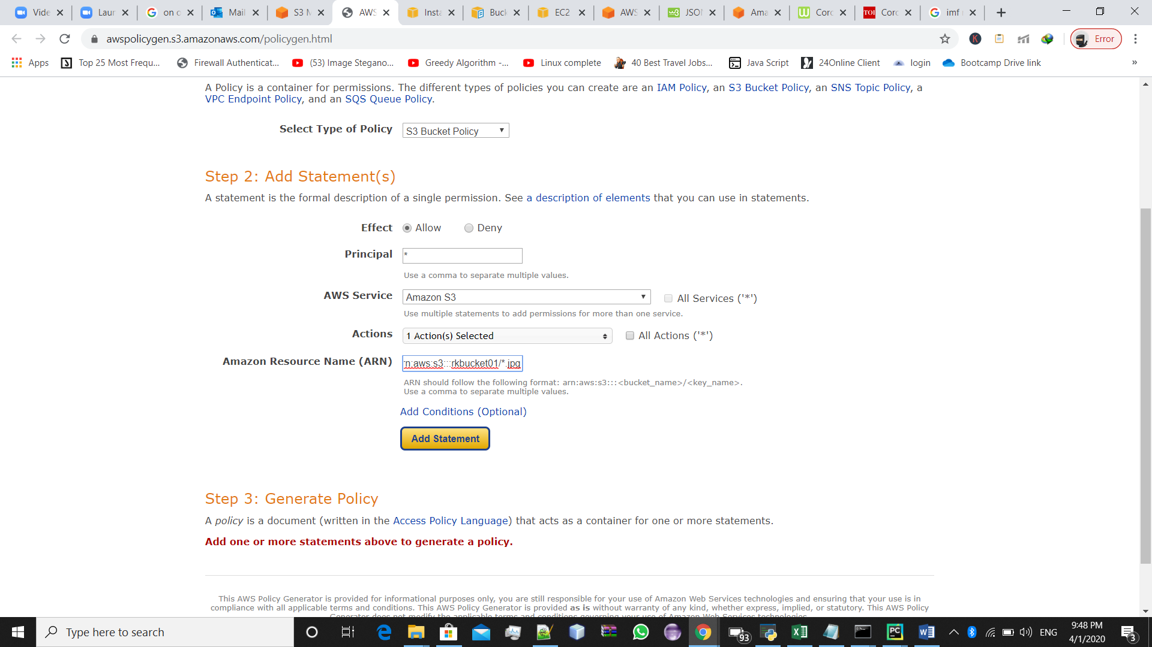

->Now Add these statement ,then generate policy script and save this.

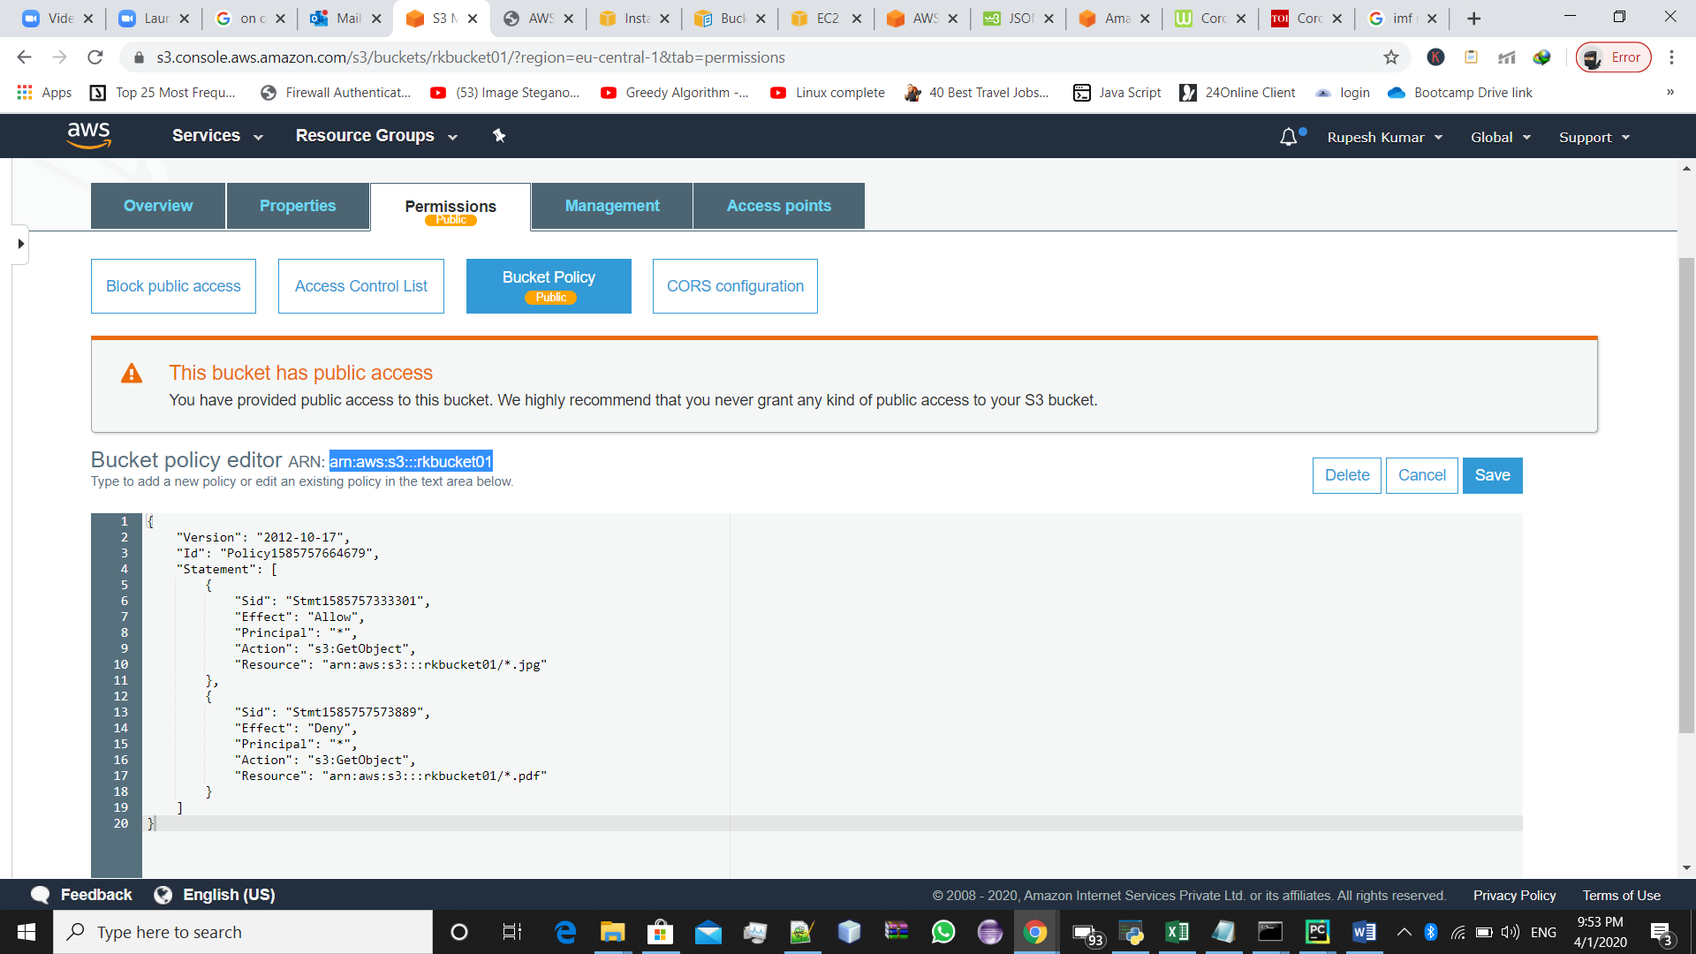

This will make the .jpg files accessible to all public users (without login). And restrict the .pdf files to the public users.

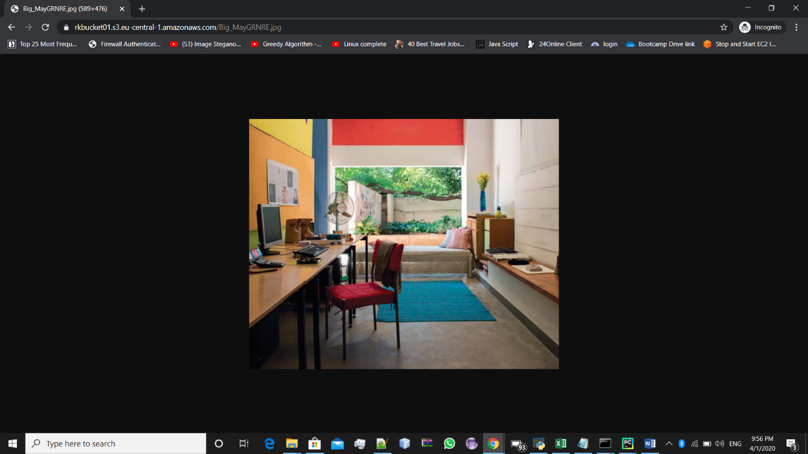Screenshot ,showing the .jpg file is accessible

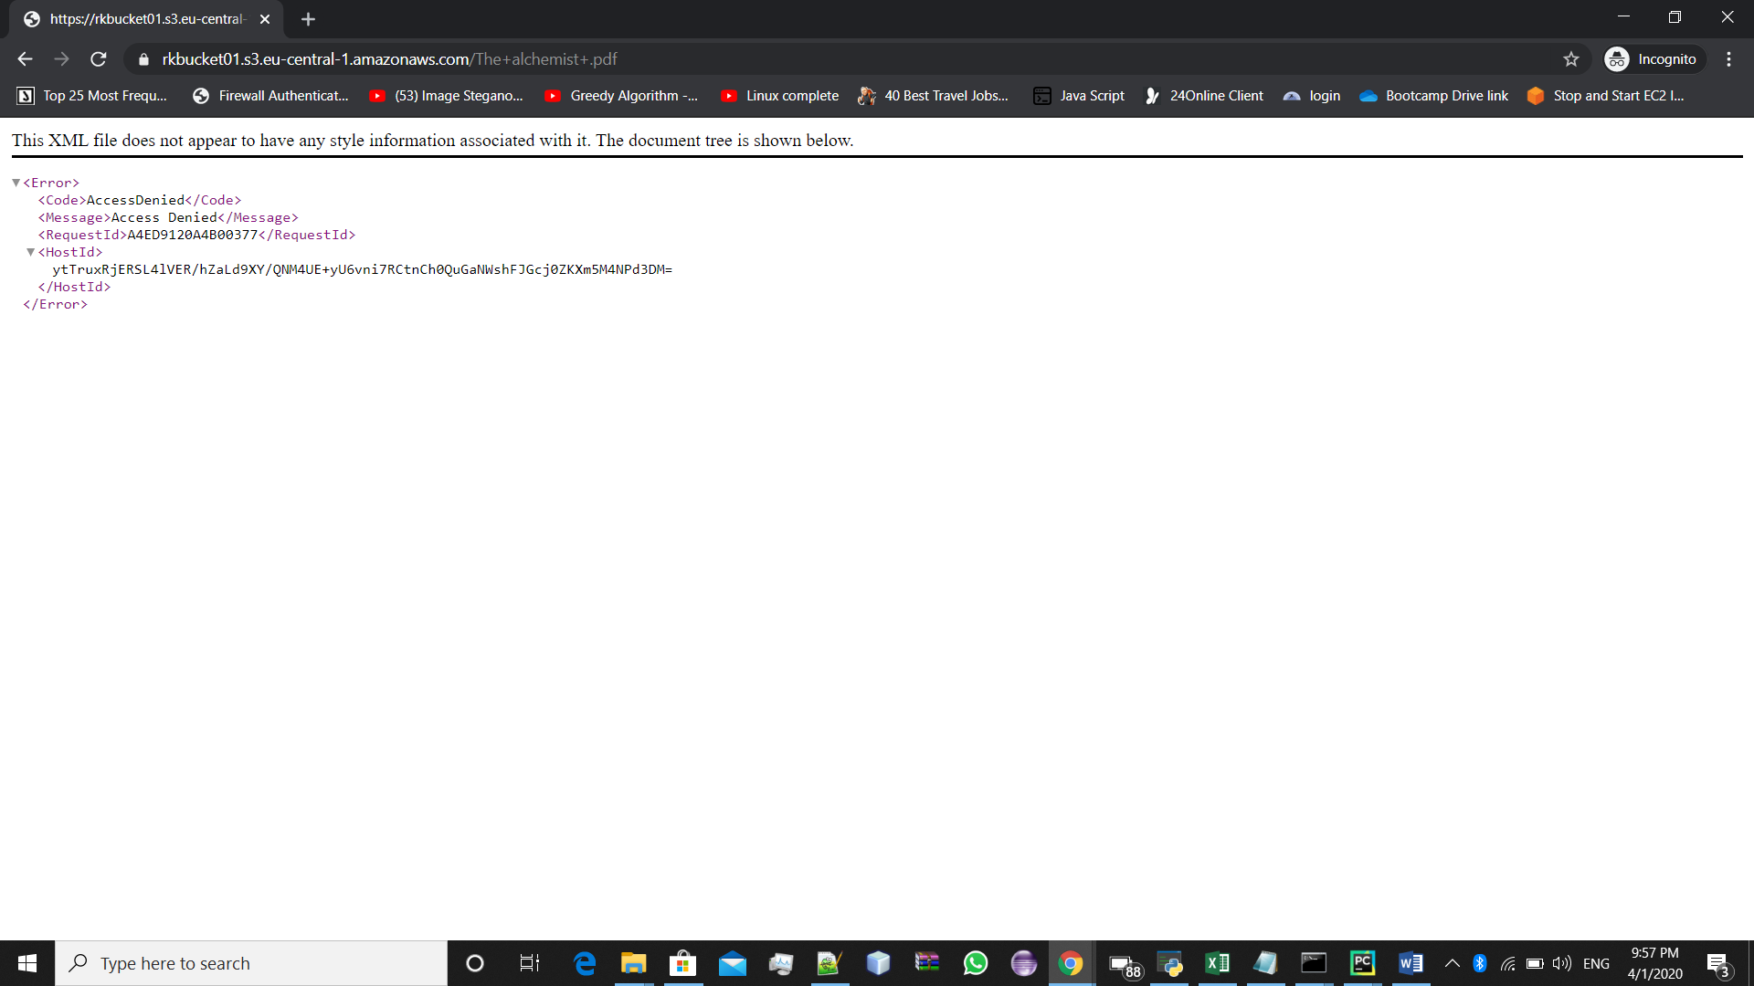 Screenshot showing .pdf file is not accessible

**Assignment 3. Completed.**

**Assignment 4 :**

Write the steps to create an autoscaling group and associate the EC2 instances of that autoscaling group with an Application load balancer. When you click on the URL of Application load balancer, it should return the content from EC2 instances.

**Steps:**

**For Launch Configuration**

1. Open EC2 service and go to **launch configuration(inside Auto Scalling).**
2. Select **Create Launch Configuration** option.
3. Choose your **AMI** then **Instance type:**
4. Then Inside **Configuration details** -> Give any name by your choice

In **Advance Details**

Under **user data**

Define the script, which will run on launching a new instance

*#!/bin/bash*

*yum update -y*

*yum install -y httpd*

*service httpd start*

*echo "Hello World !!" /var/www/html/index.html*

1. **Add Storage .**
2. Then configure the **security group** :

open **SSH** to **your IP** and,

open **HTTP** on **port 80** to **internet (0.0.0.0/0)**

1. After reviewing **,** click **launch configuration.**

**After that for Auto scaling group**

1. Select **group name, group size{start with(how many) instance} .**
2. Select **network (VPC) and any Subnets.**
3. Inside **configure policy ,**select **keep this group as its initial size.**
4. **Notification –** you can create ,if you want to have a notification for launching and terminating the instance.
5. **Configure Tags-** give any name for referring purpose.
6. After reviewing ,Create Auto Scaling.

**After that ,Create Load Balancer**

1. Select Any **load balancer** (depends upon your need:-**Classic ,HTTP,Networking**)
2. Give any name to you **Load balancer**

Select the same **VPC**, and **Security group**

1. Configure **Heath Check**

**Ping protocol : HTTP**

**Ping port : 80**

**Ping path :index.html**

1. Give any **tag**
2. After **reviewing** ,Create the **Load Balancer**

Now We can hit that http page which is creating on the starup of the EC2 Instance suing public IP .

**Assignment 4 : Completed**

**Assignment 5 :** Create a billing alarm on your account to check if your account billing exceeds $1 for the current month.

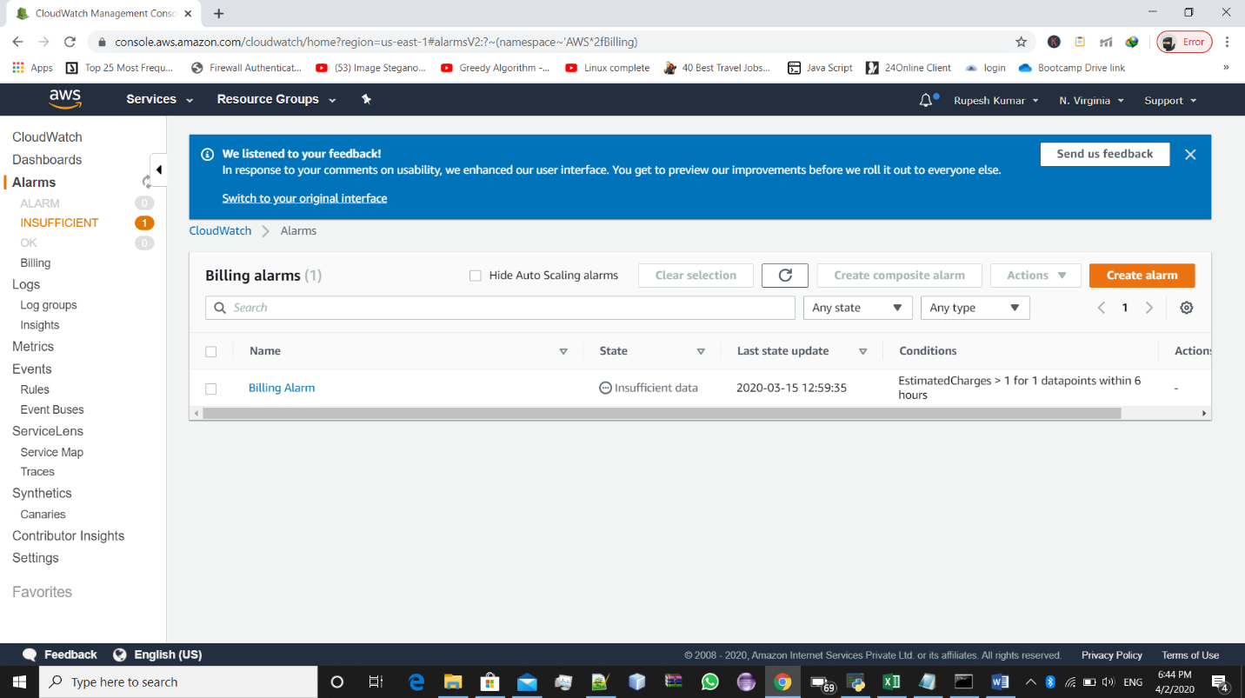=>Select **Create Alarm** inside **CloudWatch->Billing alarms**

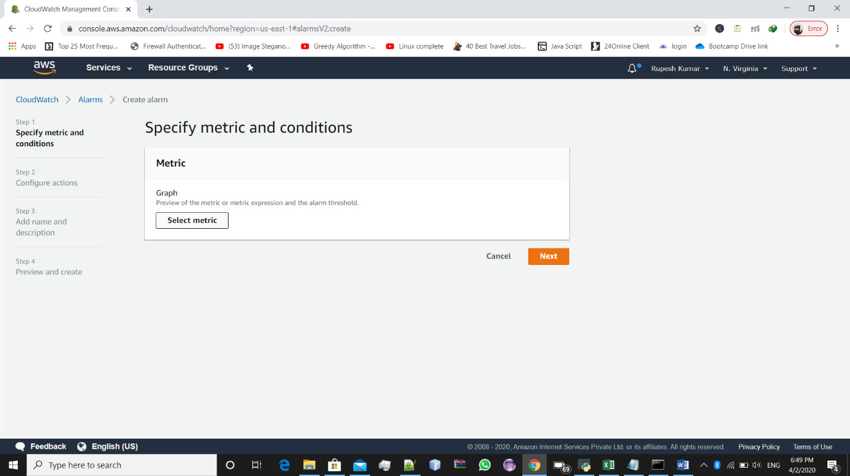=>**Select metric**

=>Choose **Select metric**. In the **All metrics** tab, choose **Billing**, **Total Estimated Charge**.

=>Select the check box next to **EstimatedCharges**, and choose **Select metric**.

=>Under **Conditions**, choose **Static**.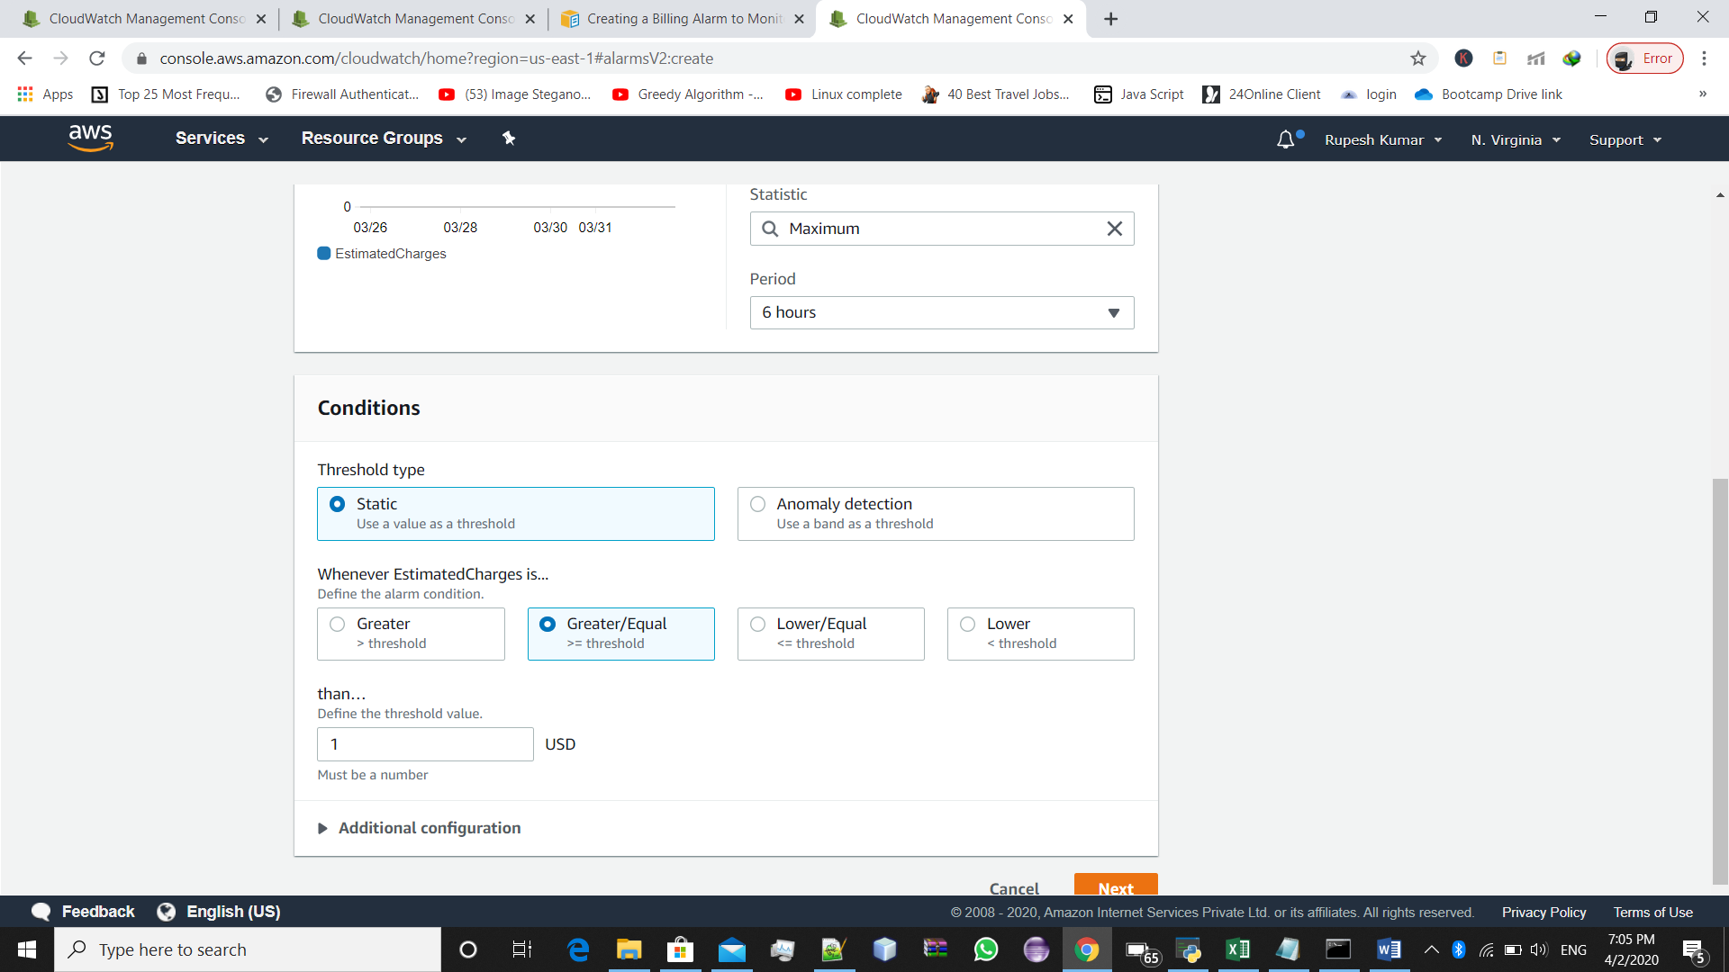

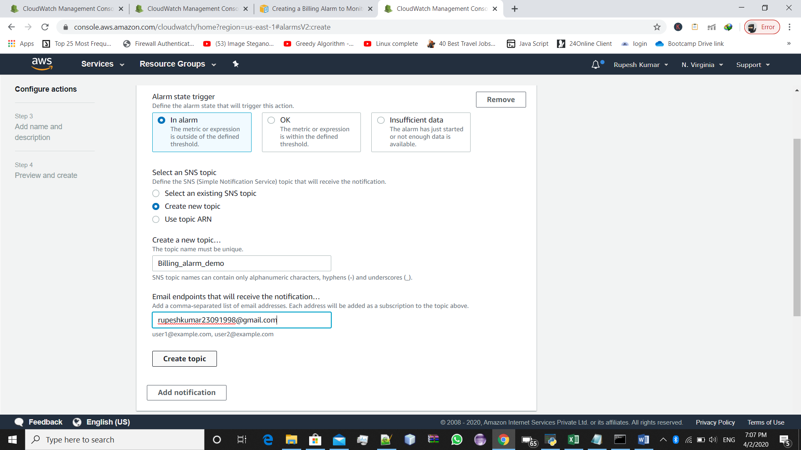=>create a new topic

=>add name and Description

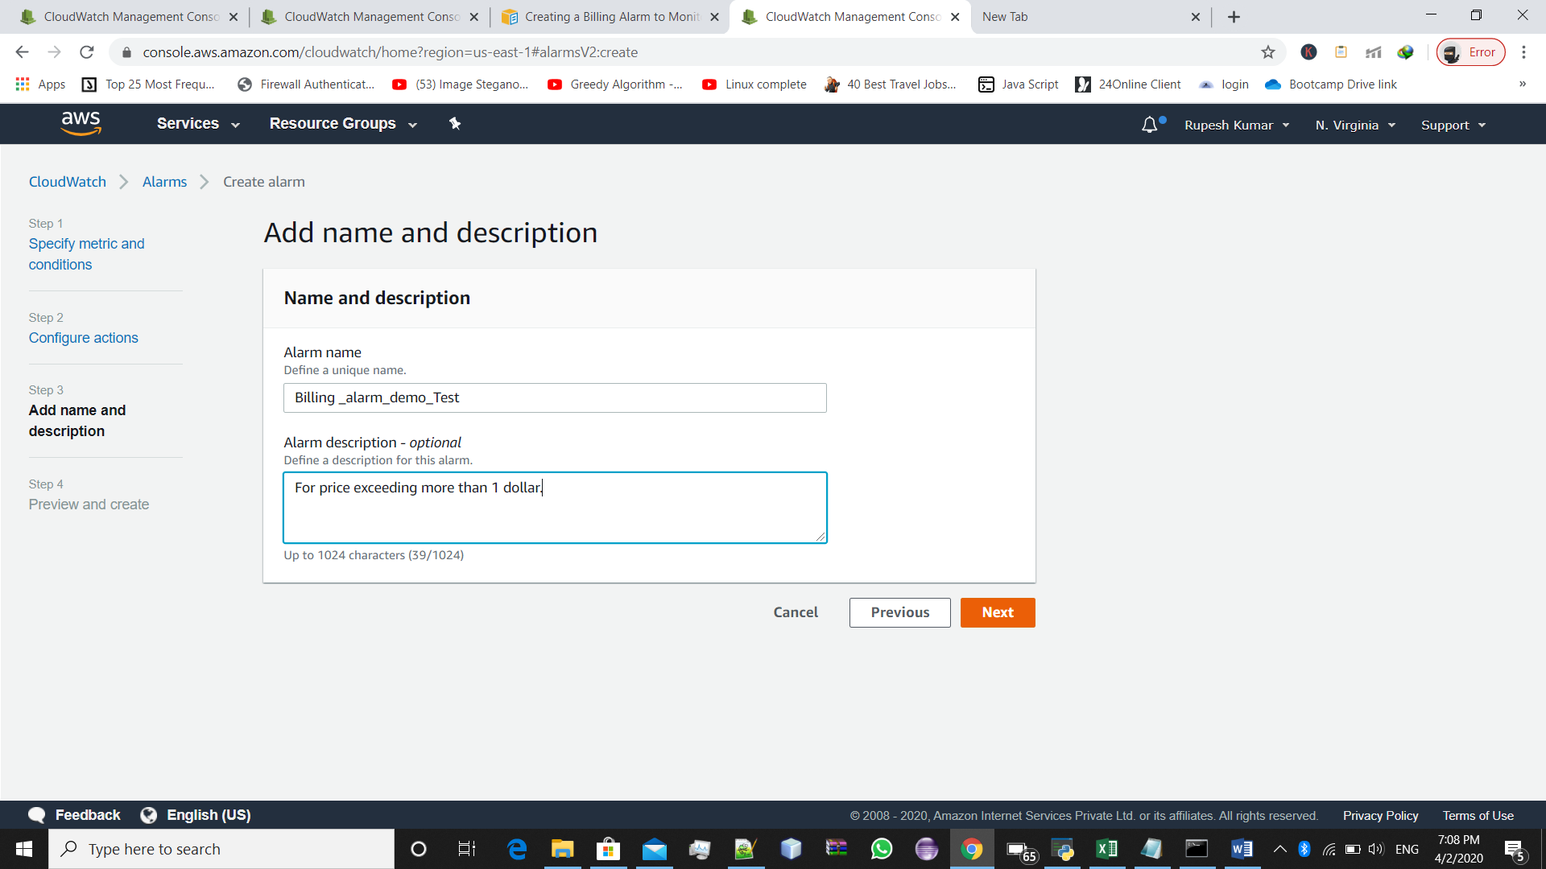

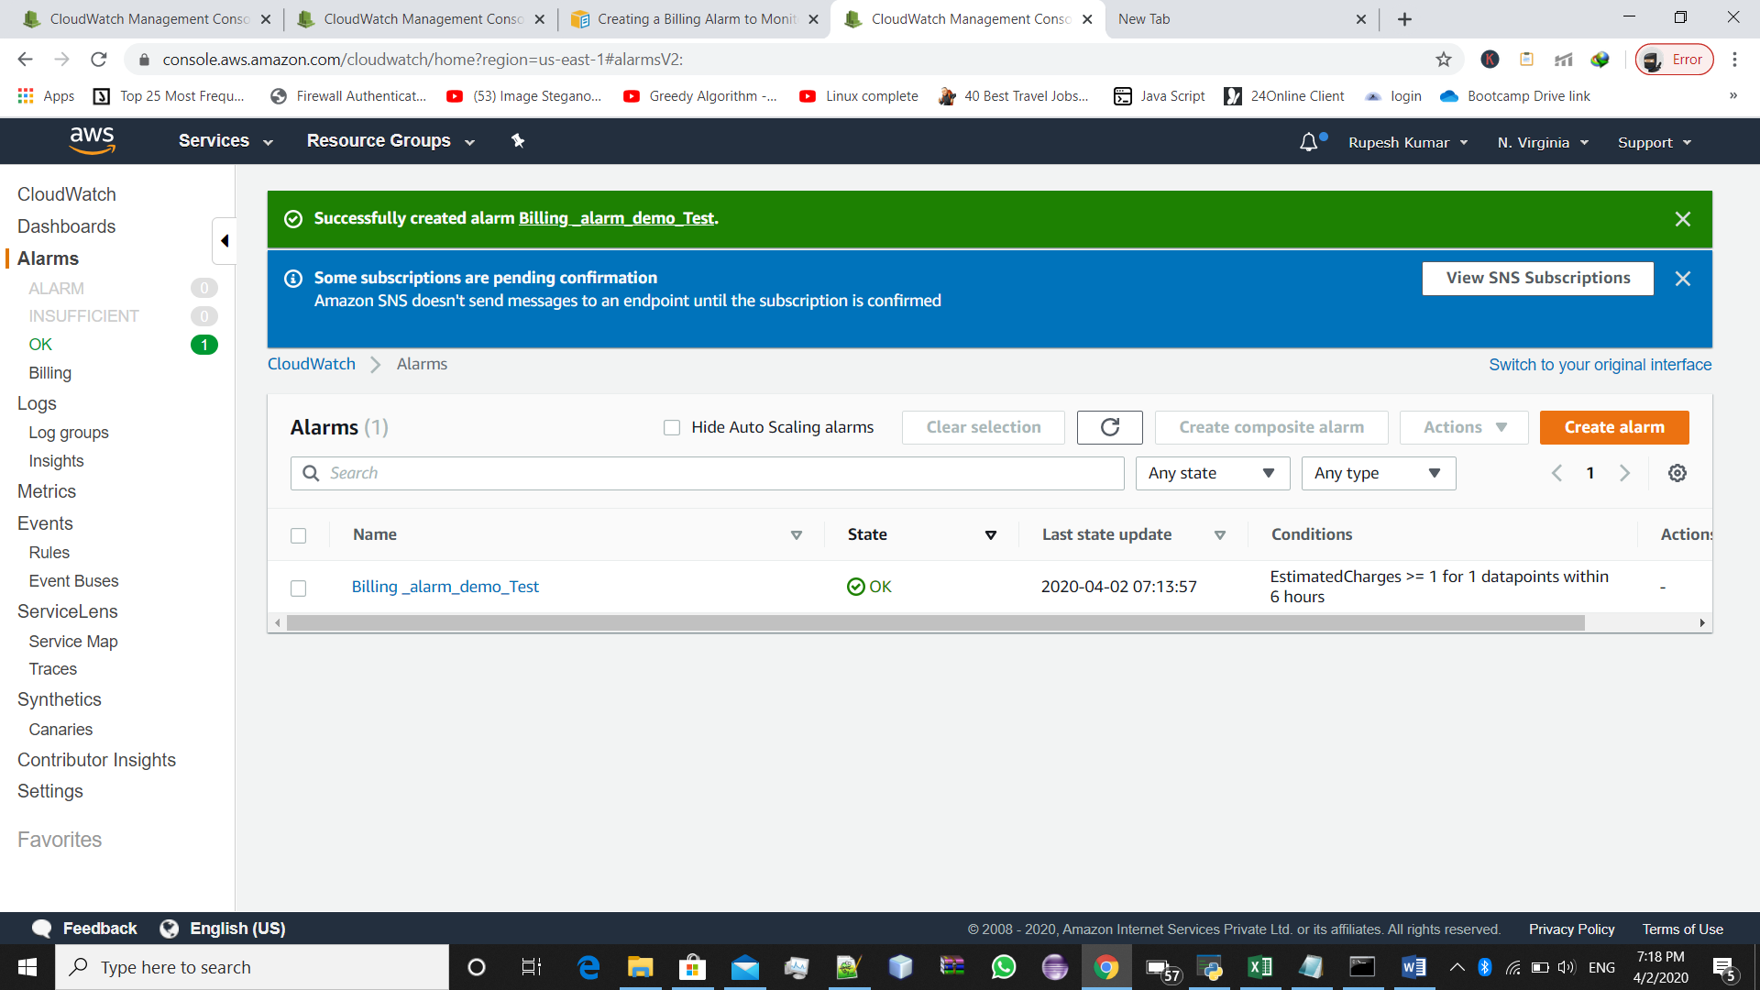=>After previe,Select create Alarm

**#Completed**

**Assignment 6:** Create an alarm on EC2 instance, to notify you if the instance is in stopped state or terminated state.

**All the steps are well shown using the screenshots:**

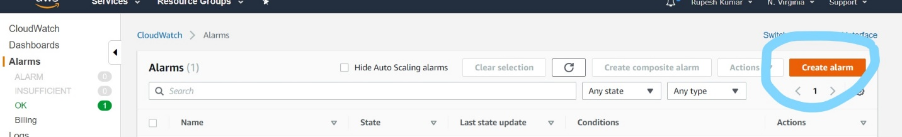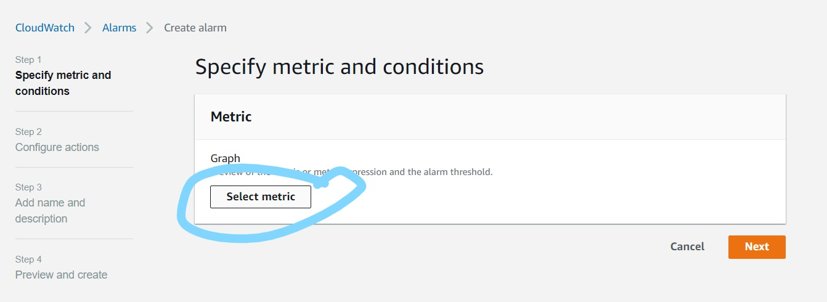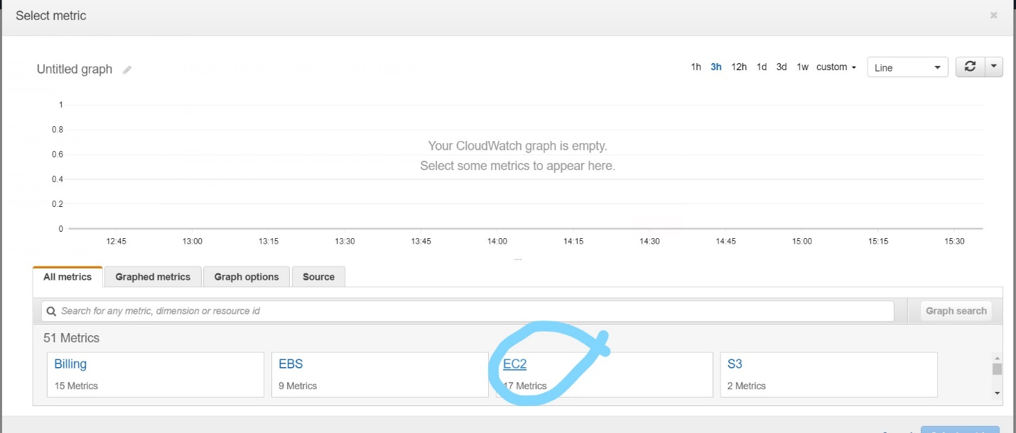

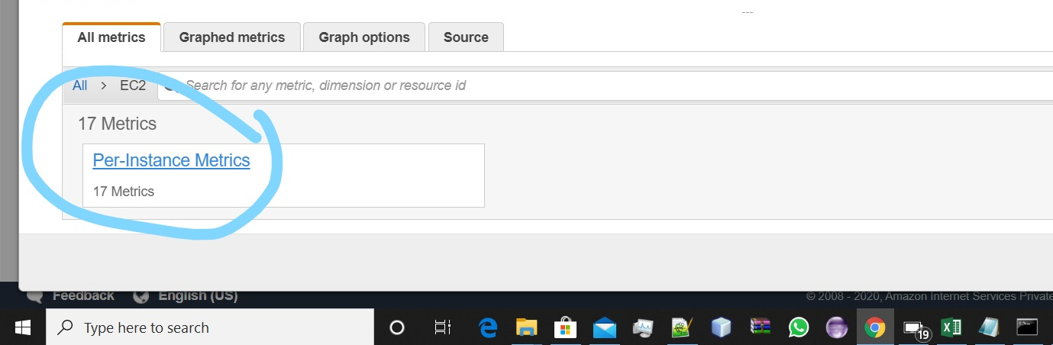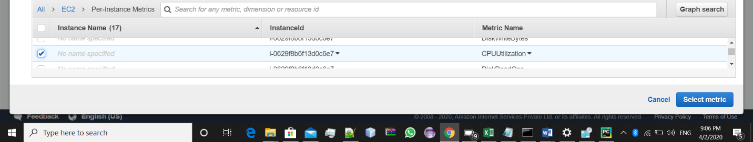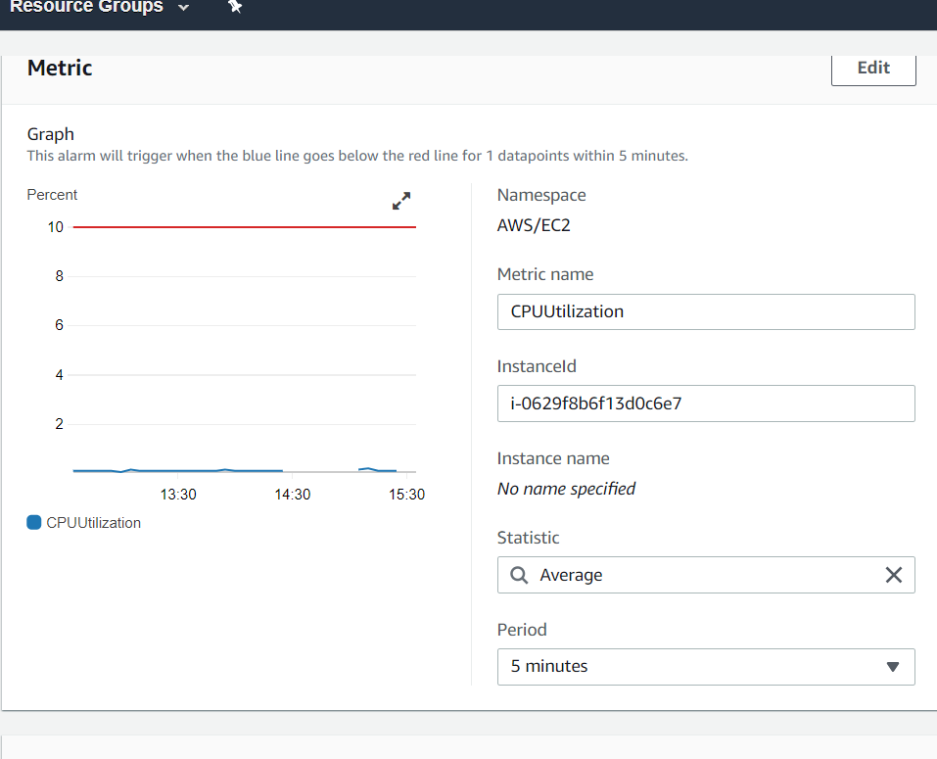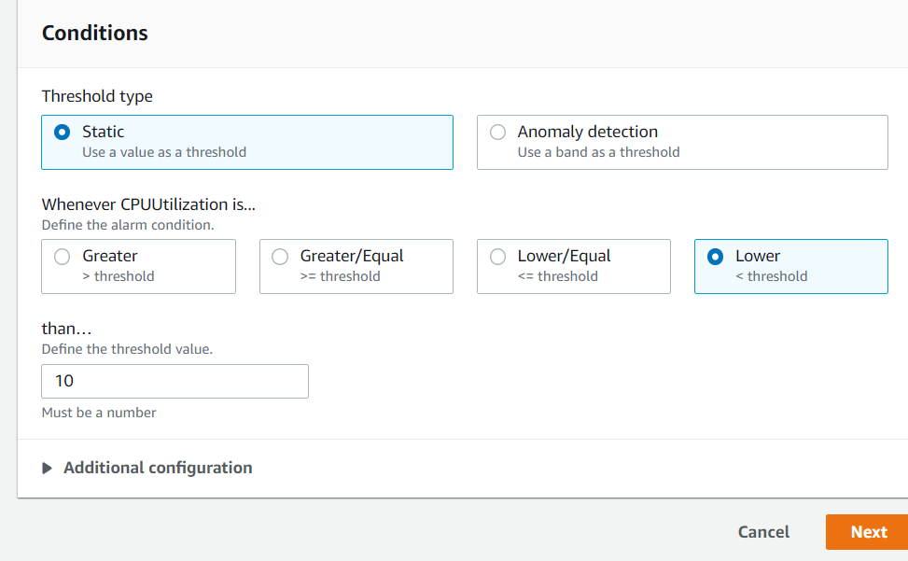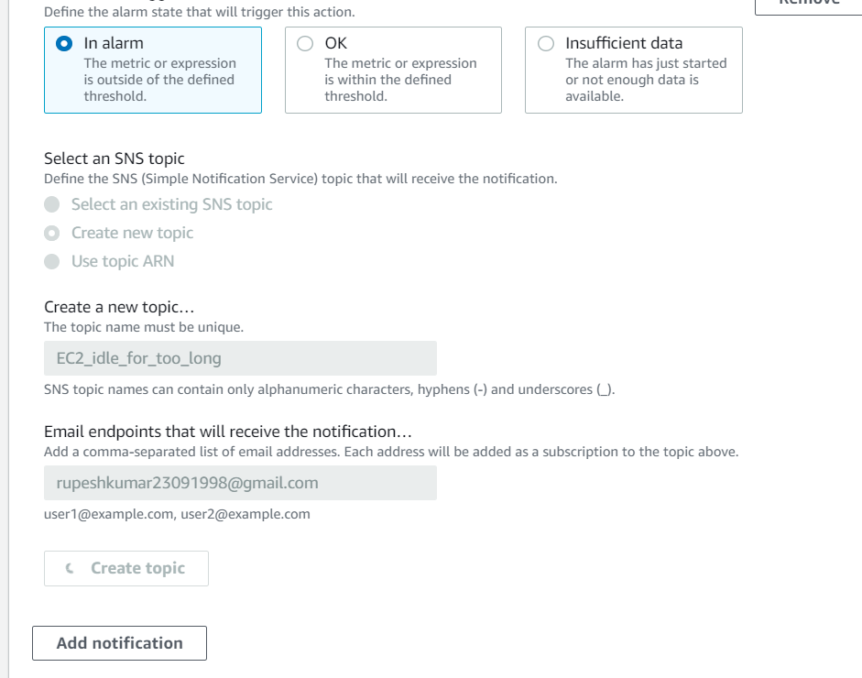

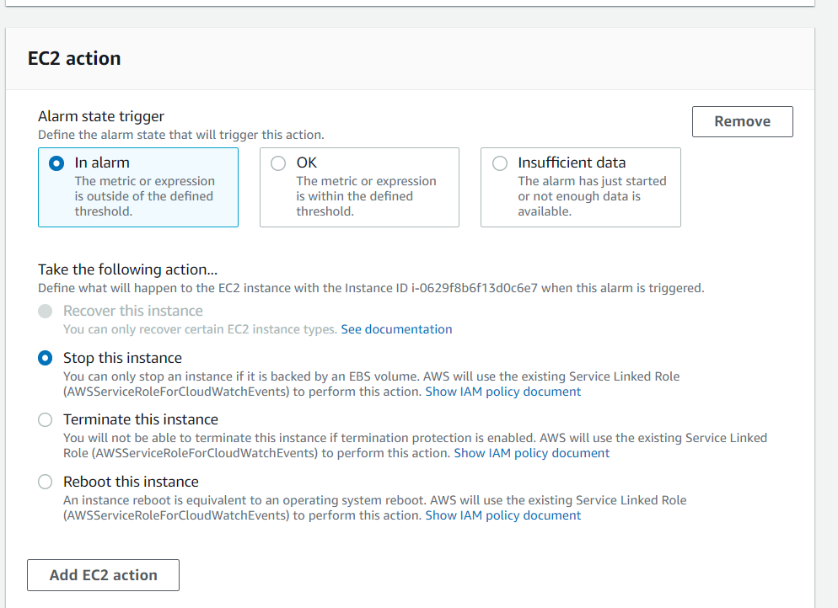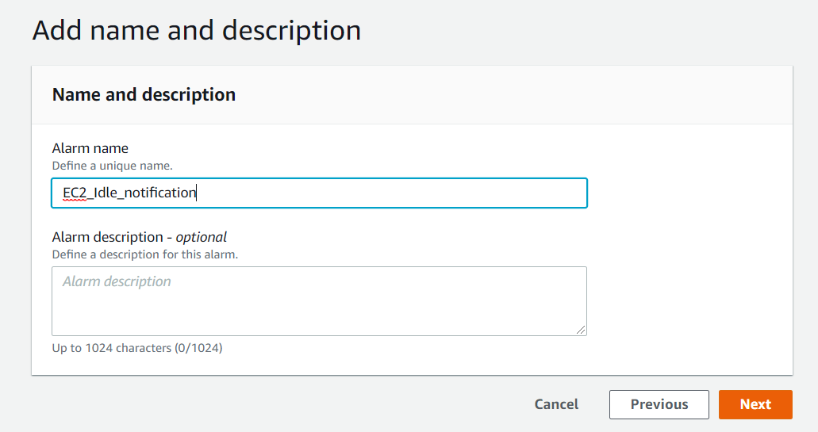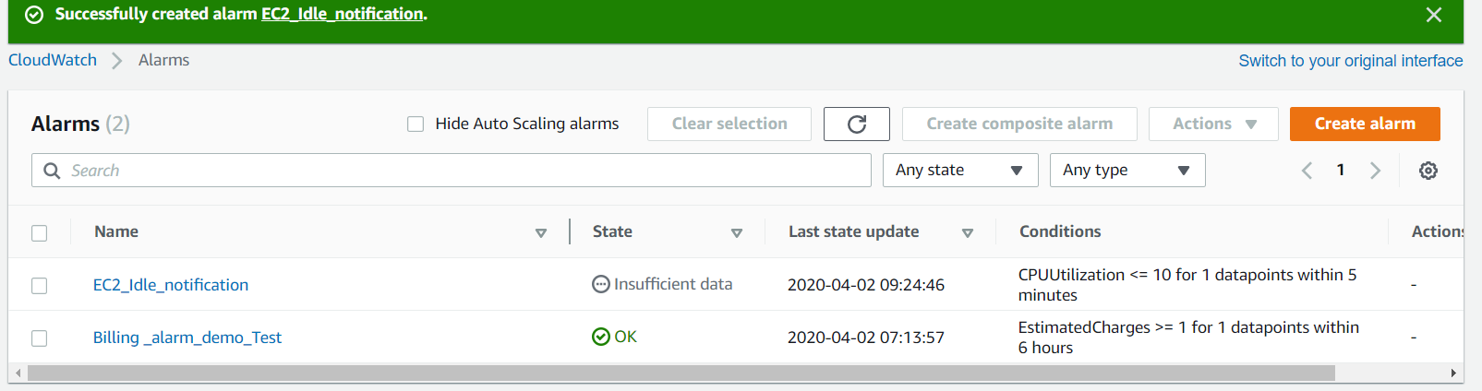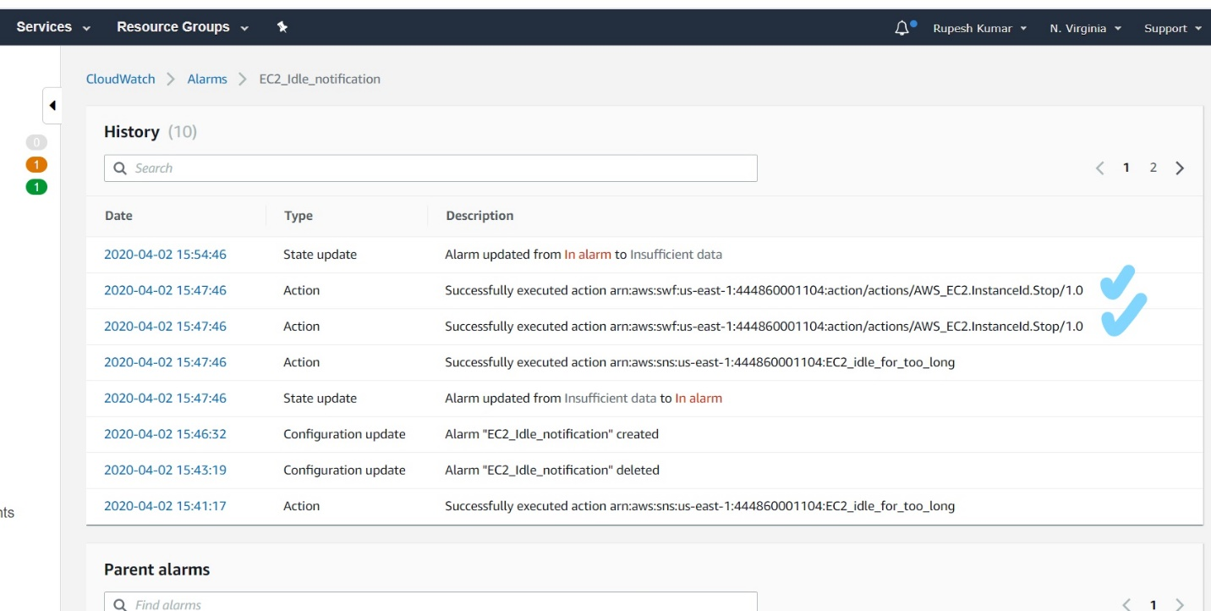

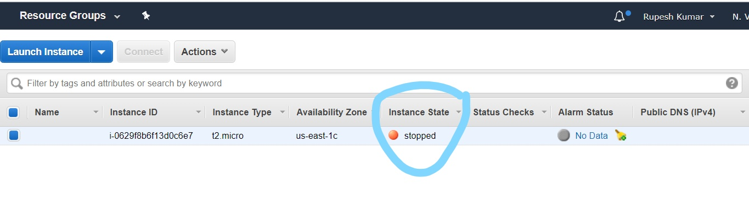

**#completed.**

**Assignment 7:** Create a custom metric on EC2, to find memory utilization of a running EC2 instance.

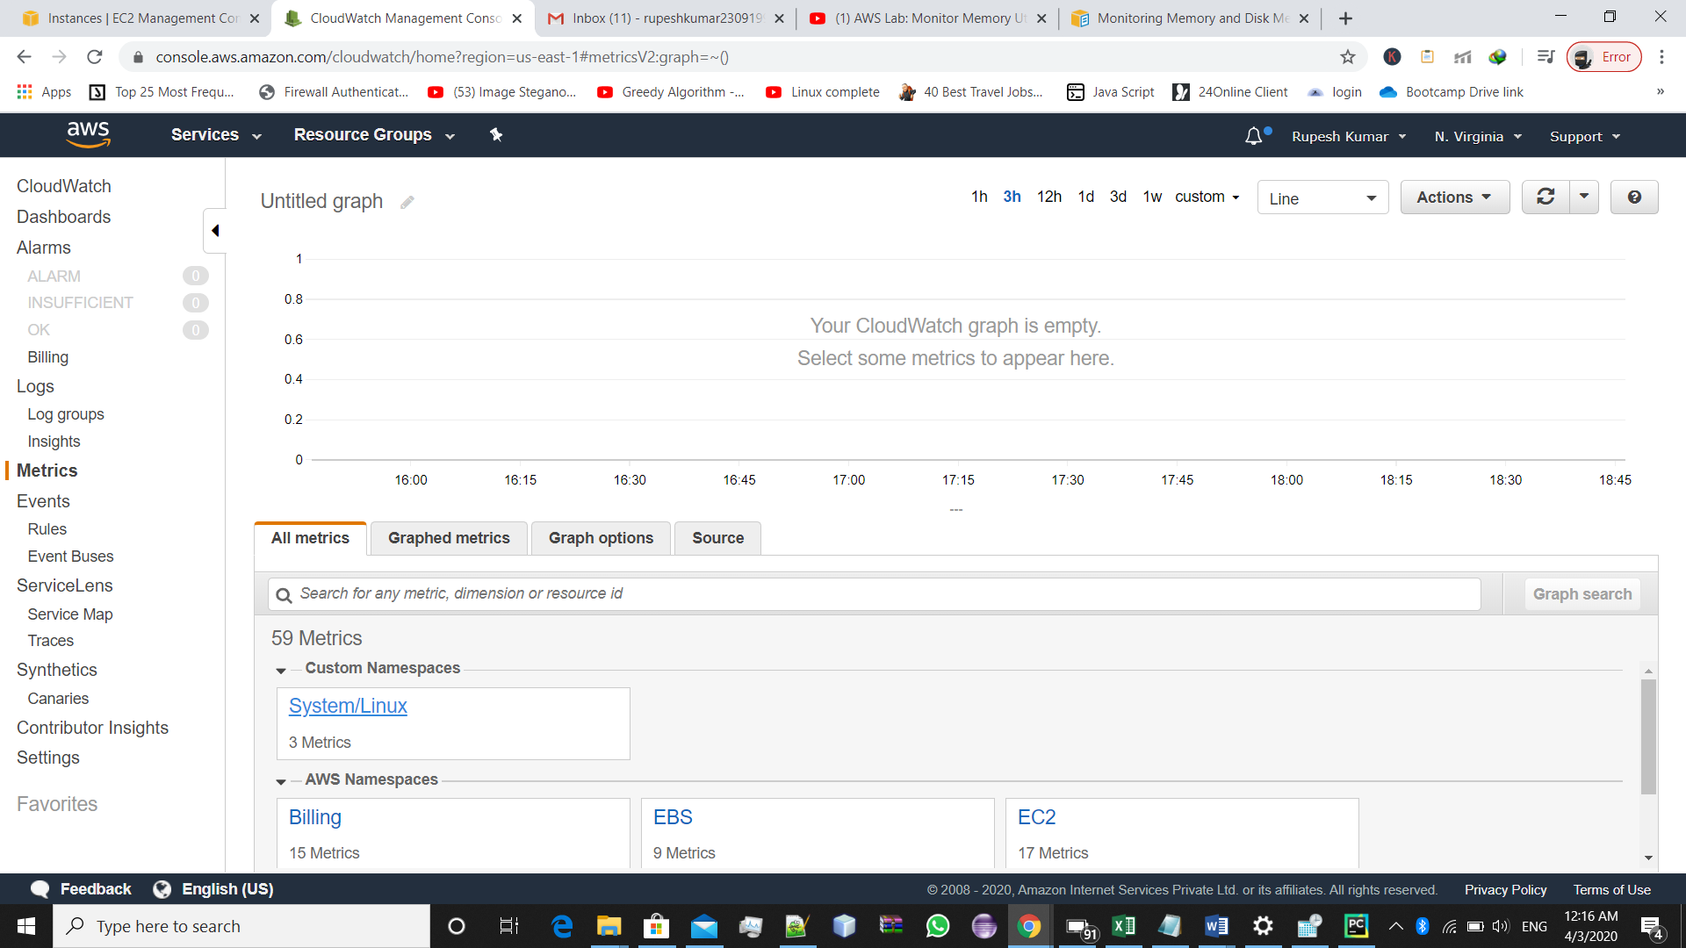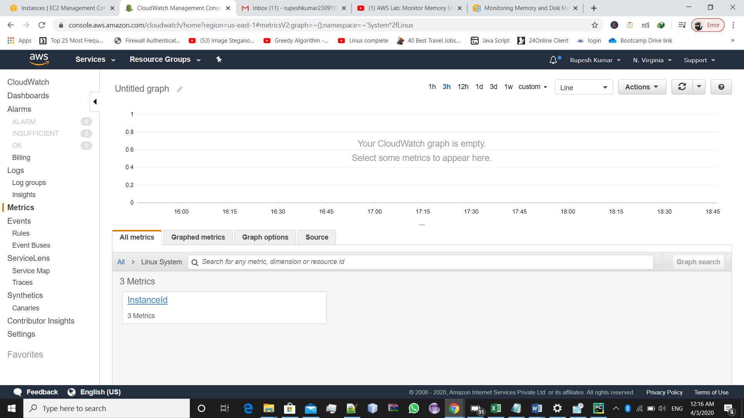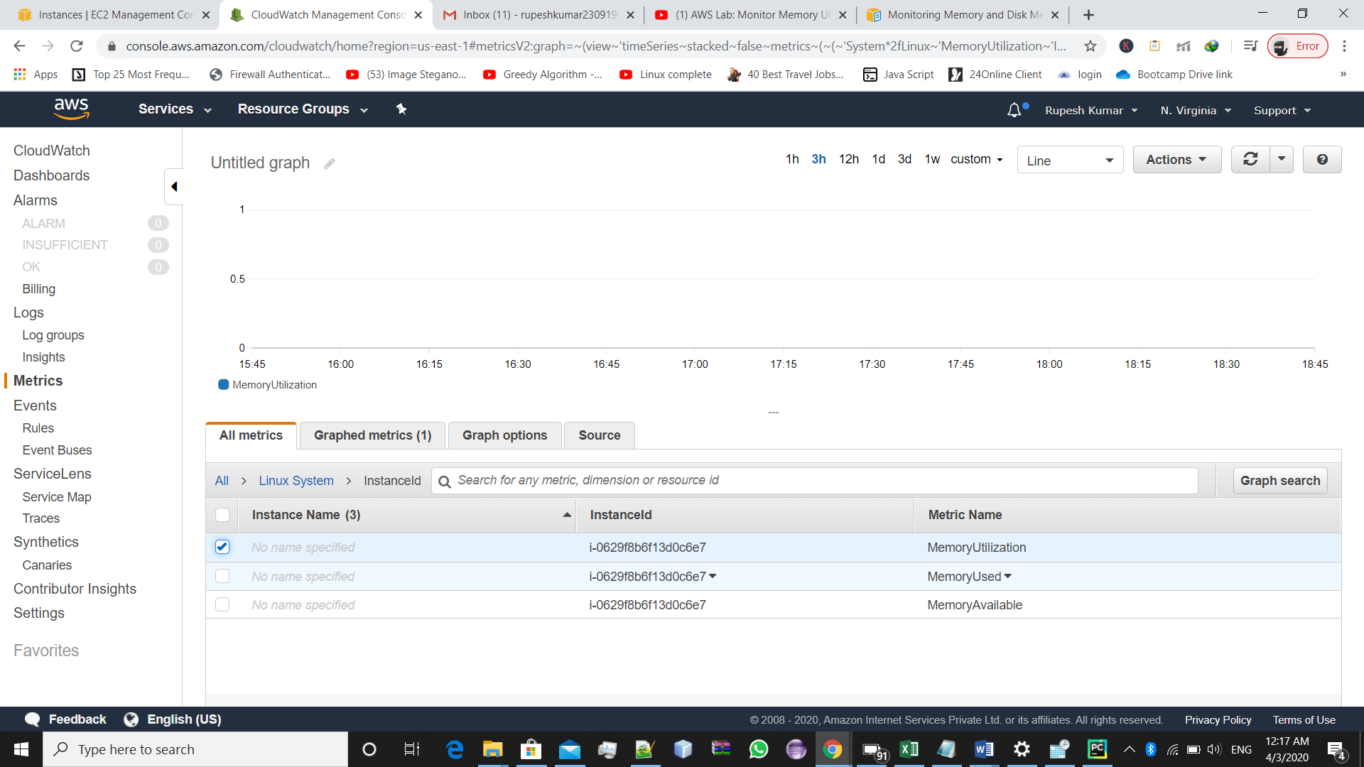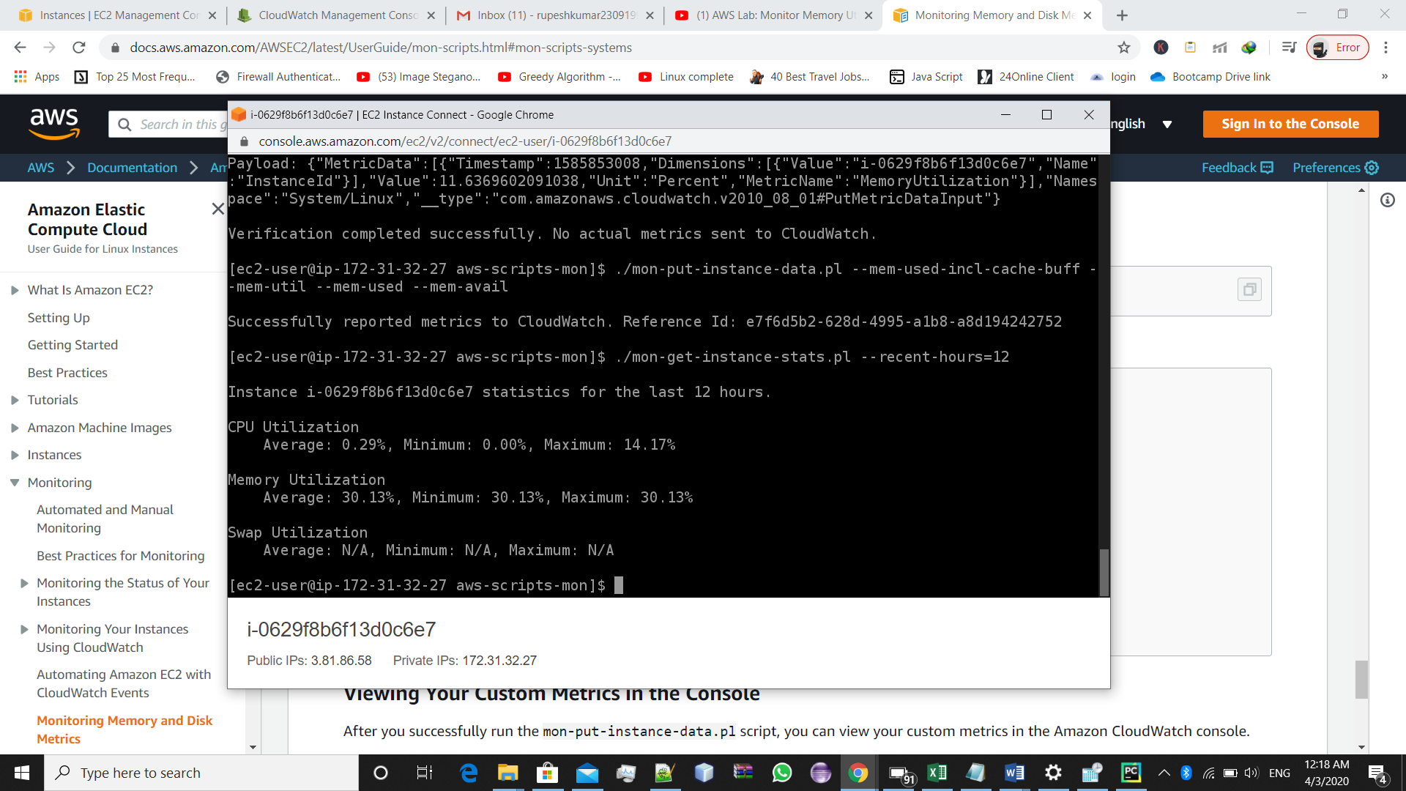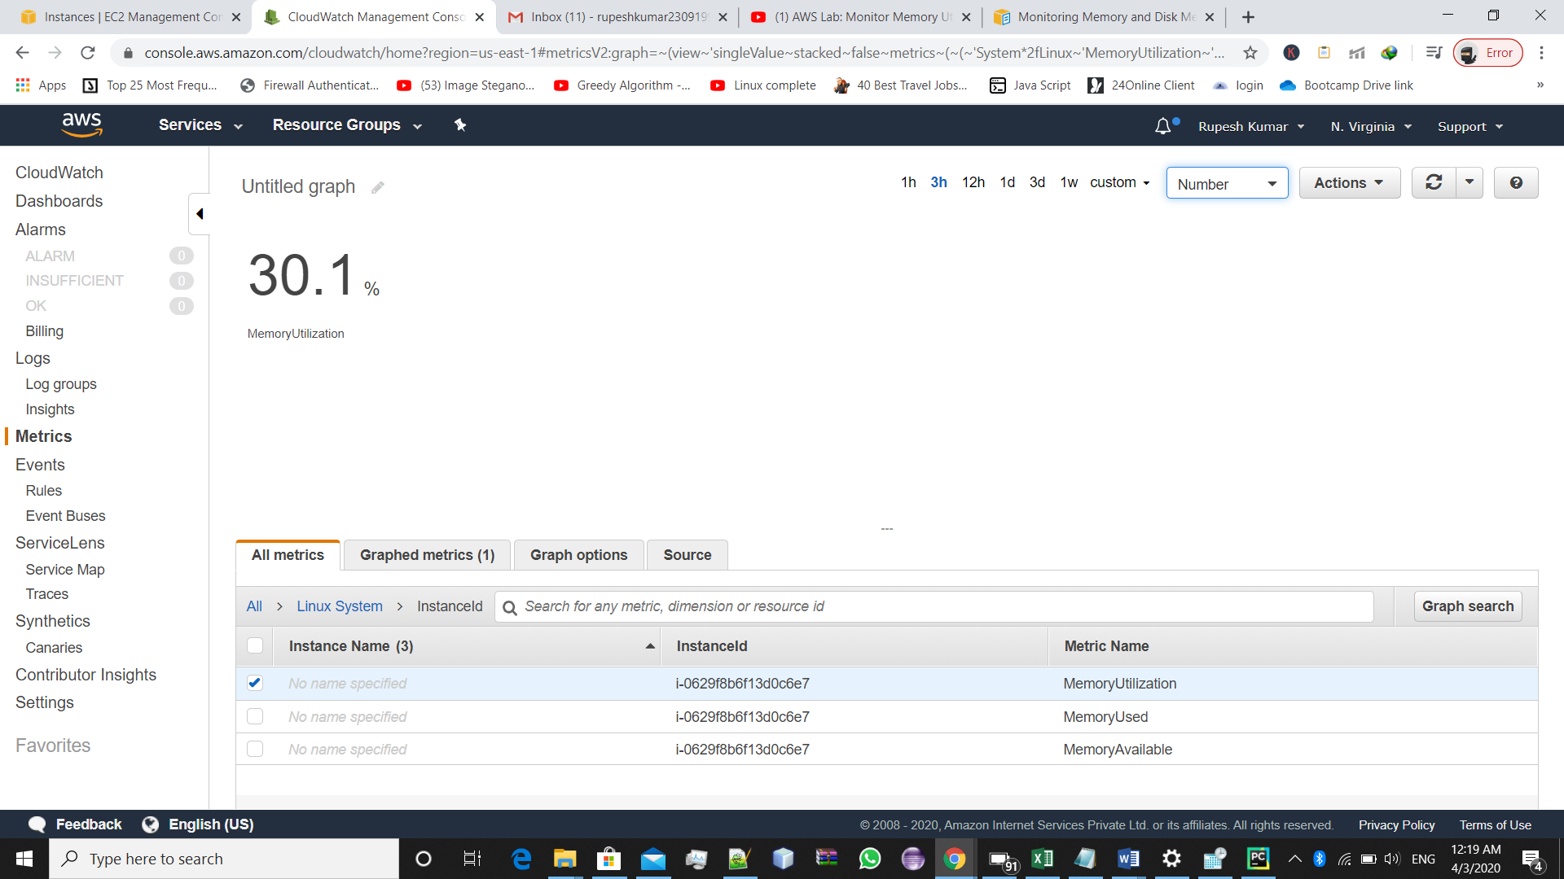

#**Completed**

**Assignment 8** : **Create a lambda function to start, stop and terminate a running EC2 instance. Also, verify the logs generated by the lambda in the Cloudwatch logs to check whether the lambda execution is done properly.**

->For doing this assignment ,first we should have a instance for checking our lambda function,

In our case,we have this EC2 instance running in eu-central-1 region.

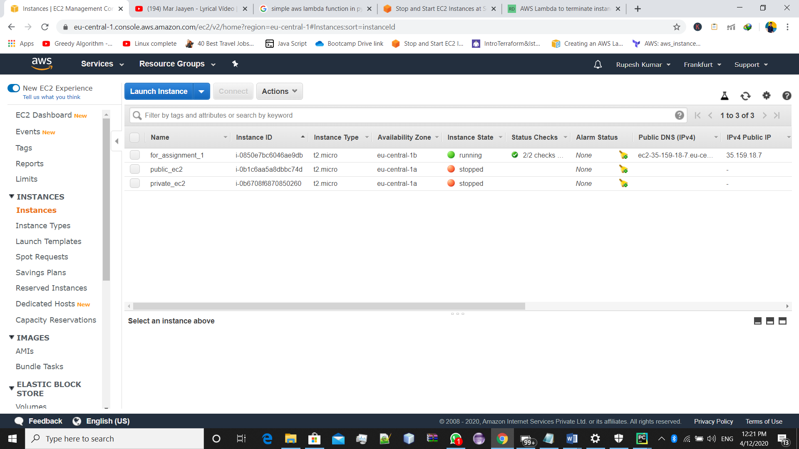

->you should have a role already created in with following script:

[Create an IAM policy using the JSON policy editor](https://docs.aws.amazon.com/IAM/latest/UserGuide/access_policies_create.html#access_policies_create-json-editor). Paste this JSON policy document into the policy editor:

{

"Version": "2012-10-17",

"Statement": [

{

"Effect": "Allow",

"Action": [

"logs:CreateLogGroup",

"logs:CreateLogStream",

"logs:PutLogEvents"

],

"Resource": "arn:aws:logs:*:*:*"

},

{

"Effect": "Allow",

"Action": [

"ec2:Start*",

"ec2:Stop*"

],

"Resource": "*"

}

]

}

This policy will help to start and stop the instance.

->Now **OPEN pyCharm ->** create stopEc2.py file ,in which we will write the source code to stop the instance.

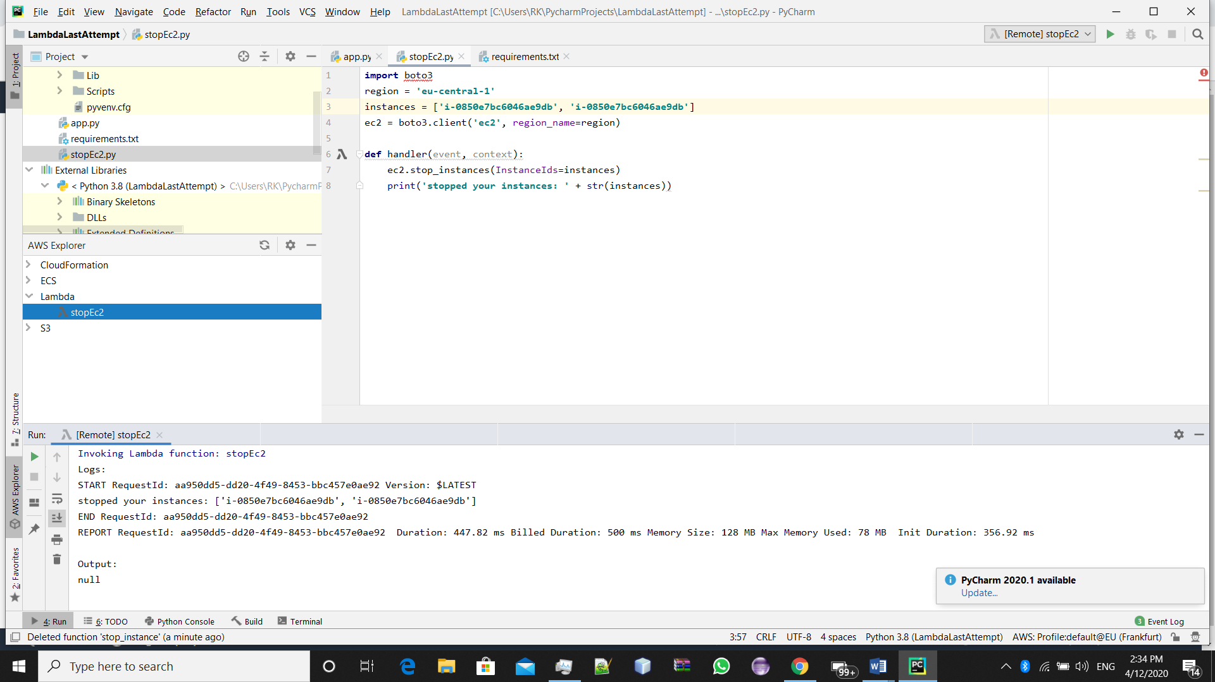

Change you region and instance id accordingly.

-> and inside **AWS explorer** ,select **lambda** and **create new Lambda function** (make sure , in your pucharm aws kit being install and aws configuration has been done ,otherwise you wont we able to access the aws explorer).

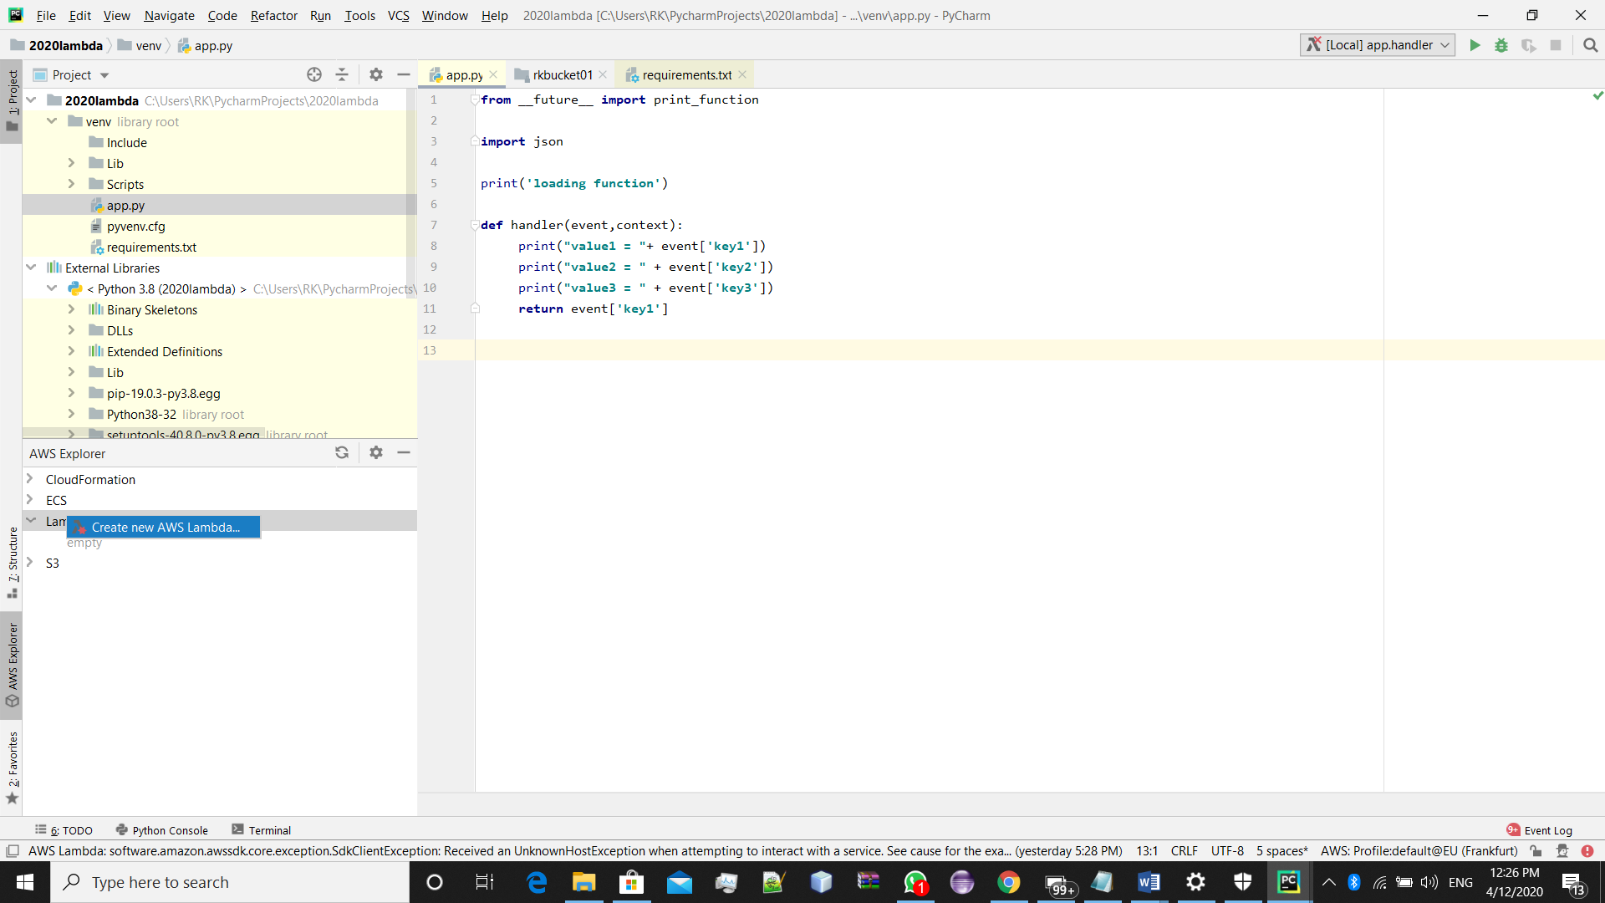

->Now ,fill accordingly (make sure your handler name should be same as you .py file , which you have created above, and hit the **Create Function**

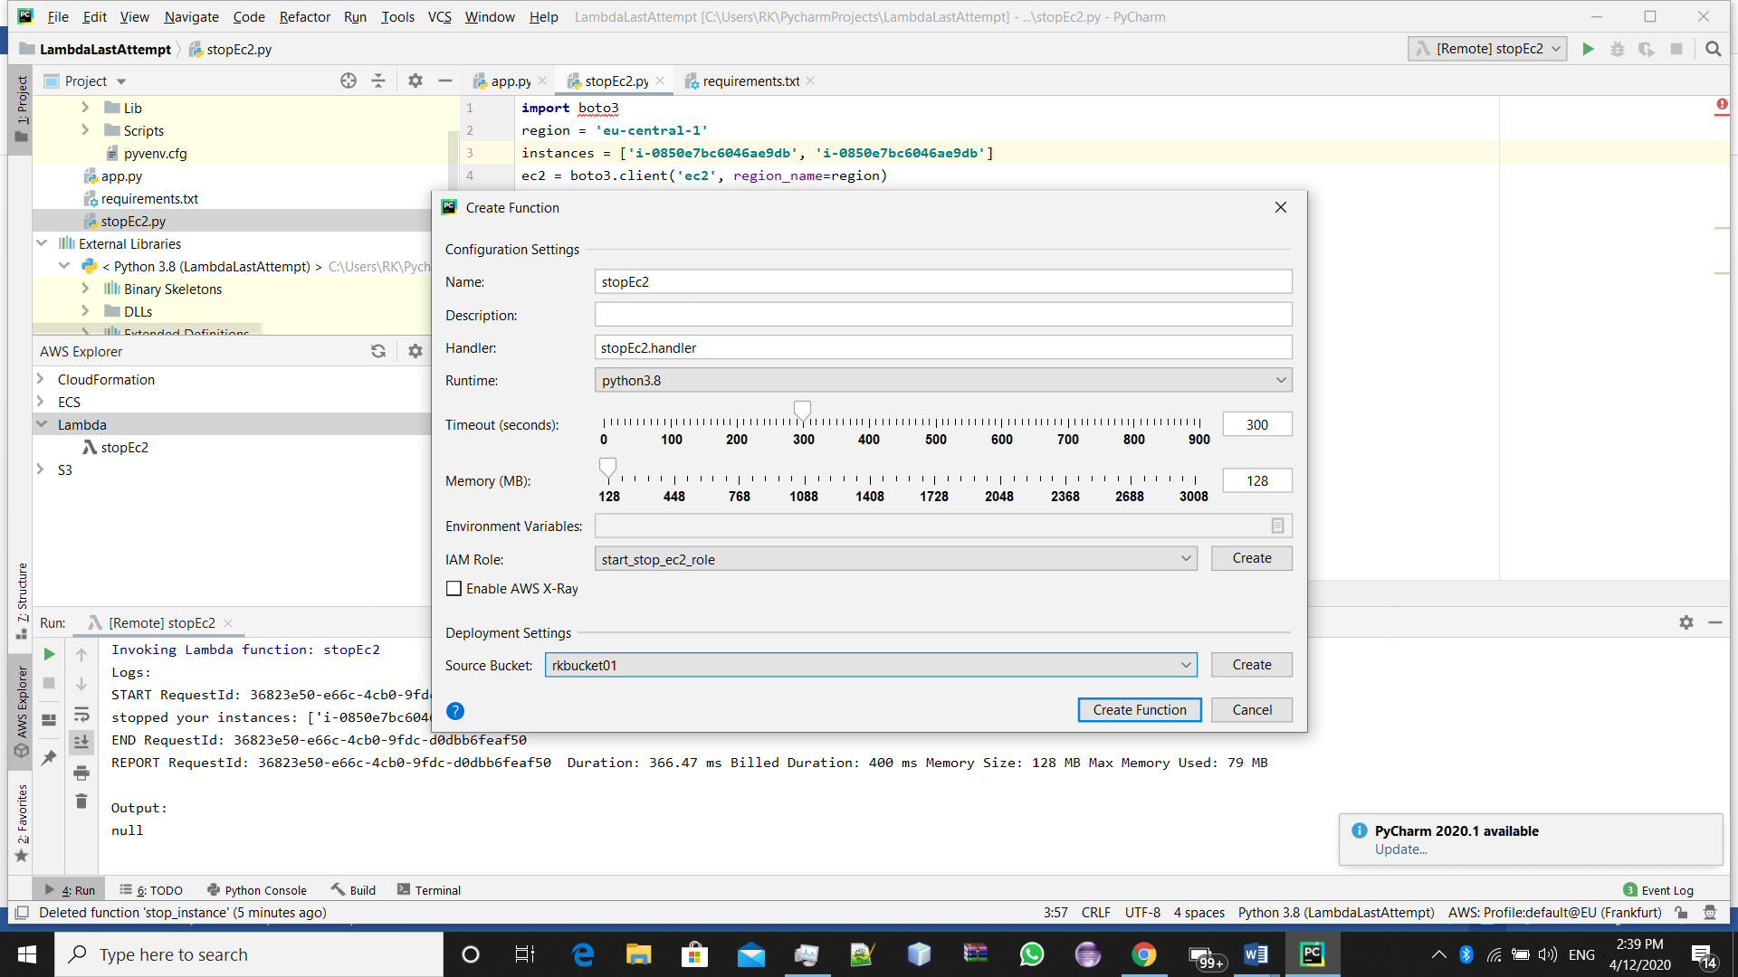

->Now, Run the function

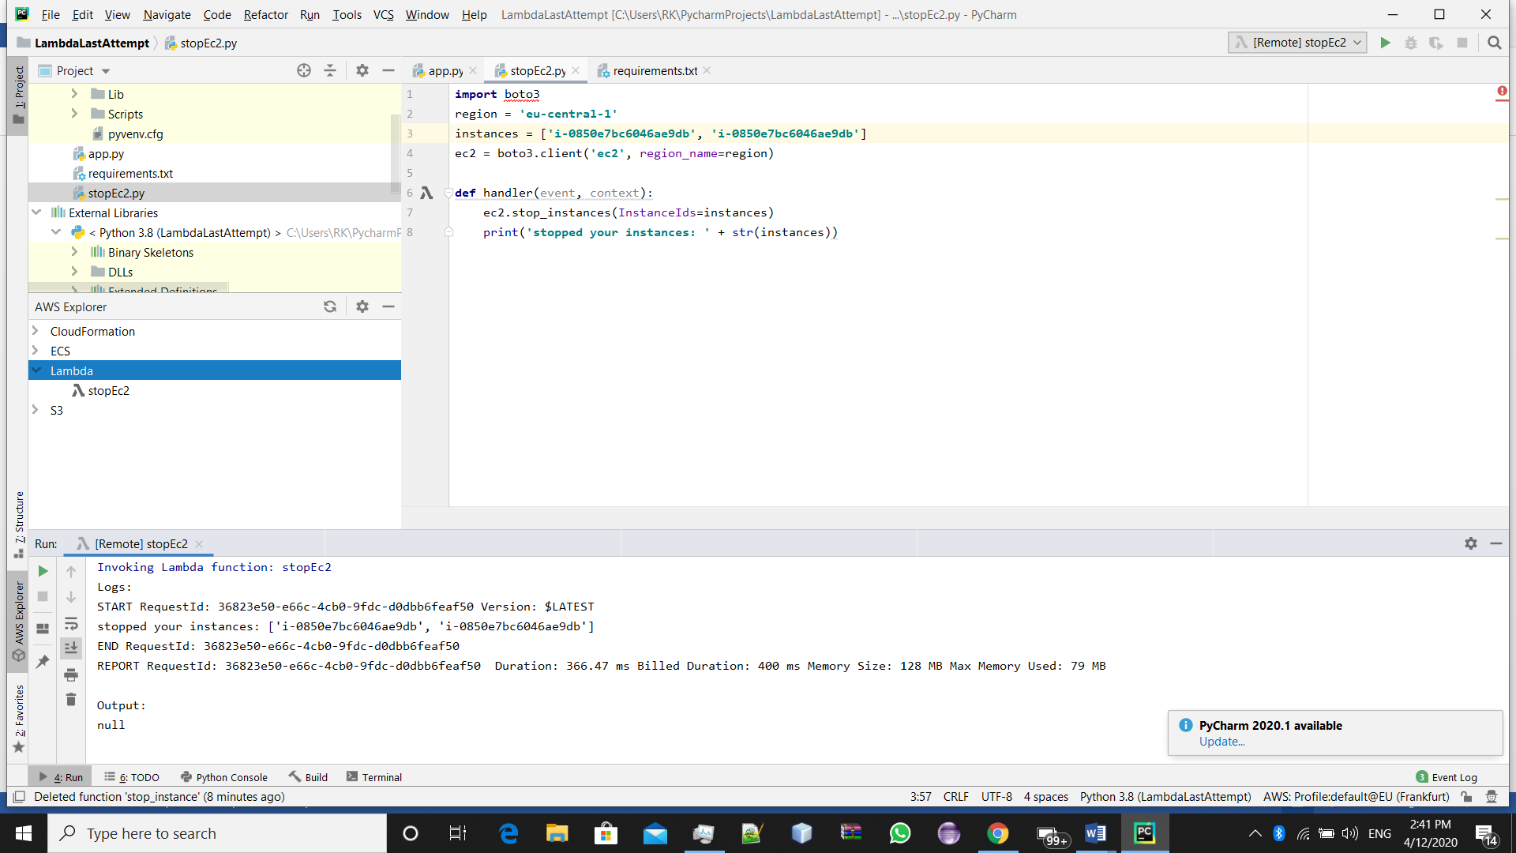

This should be the you output, now our instance is stopped ,we can check that in our aws console also.

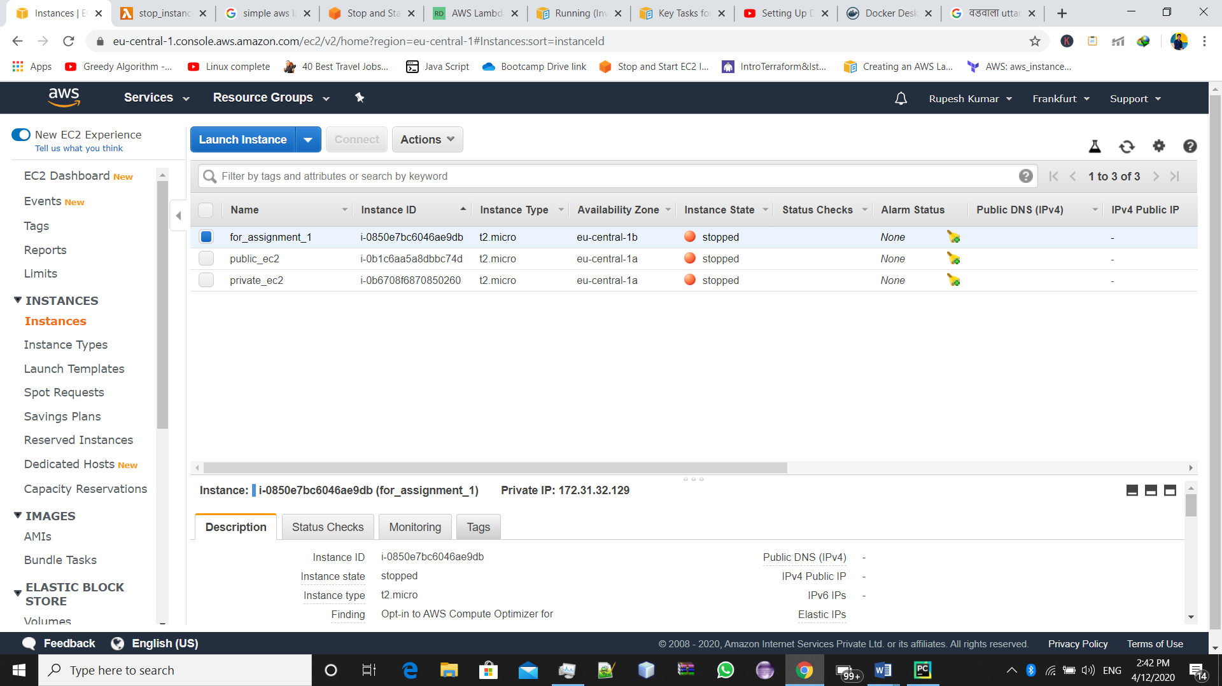

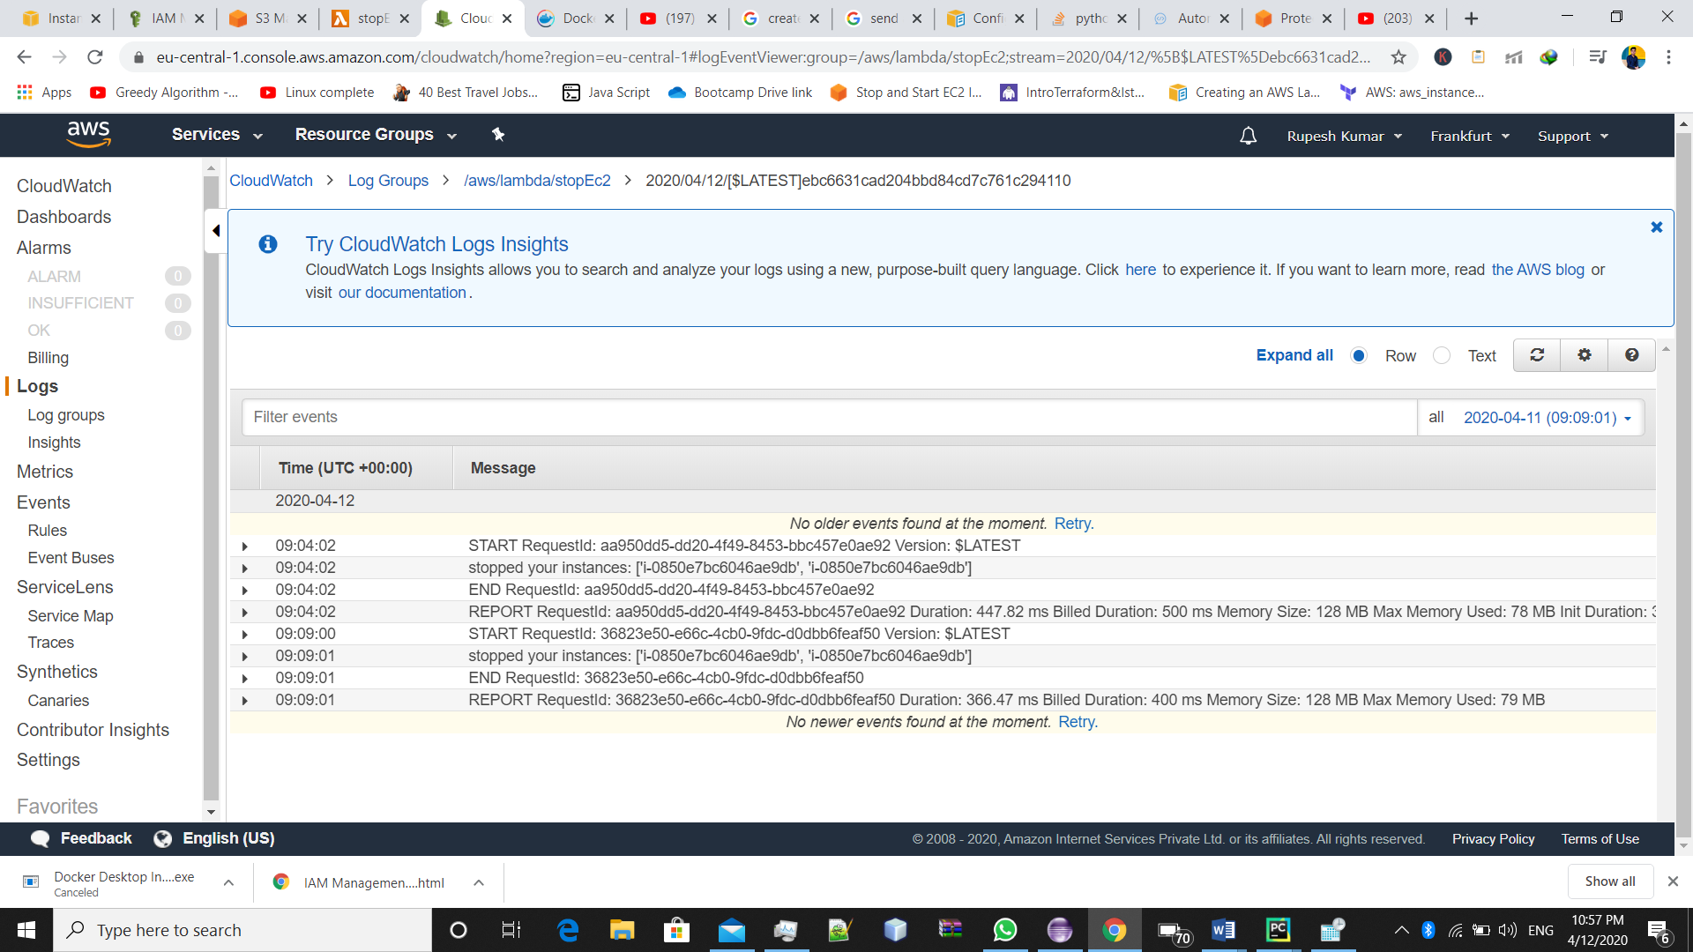

These are the cloudWatch logs for stop function.

Similar to that ,

We can create a function, that can start our function

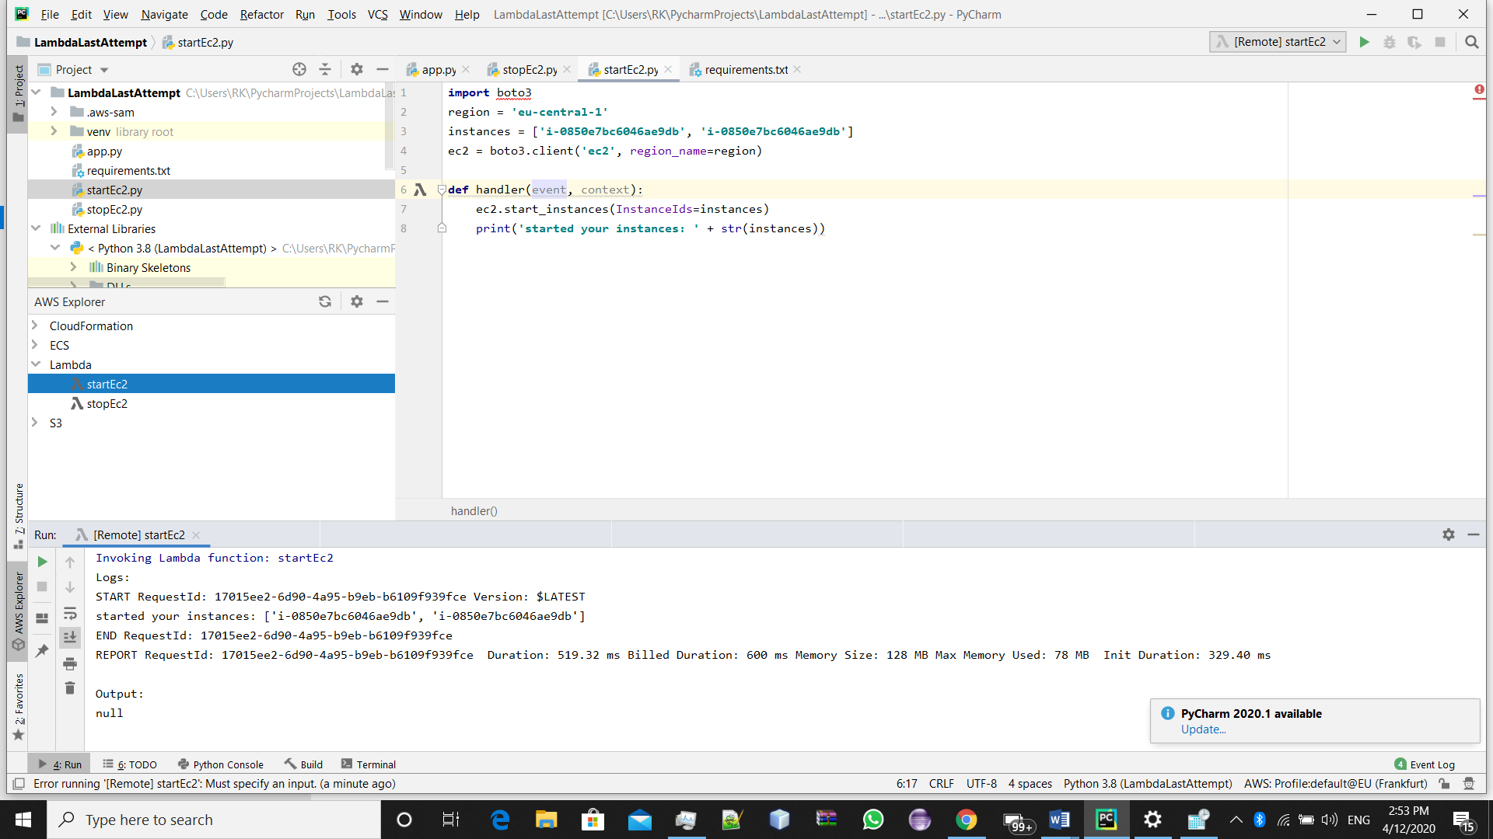

This is the code with execution logs to start the instance.

For terminating the instance(just change the code with

{ ec2.terminate_instance(InstanceIds=instances)} in line 7 and follow same steps.

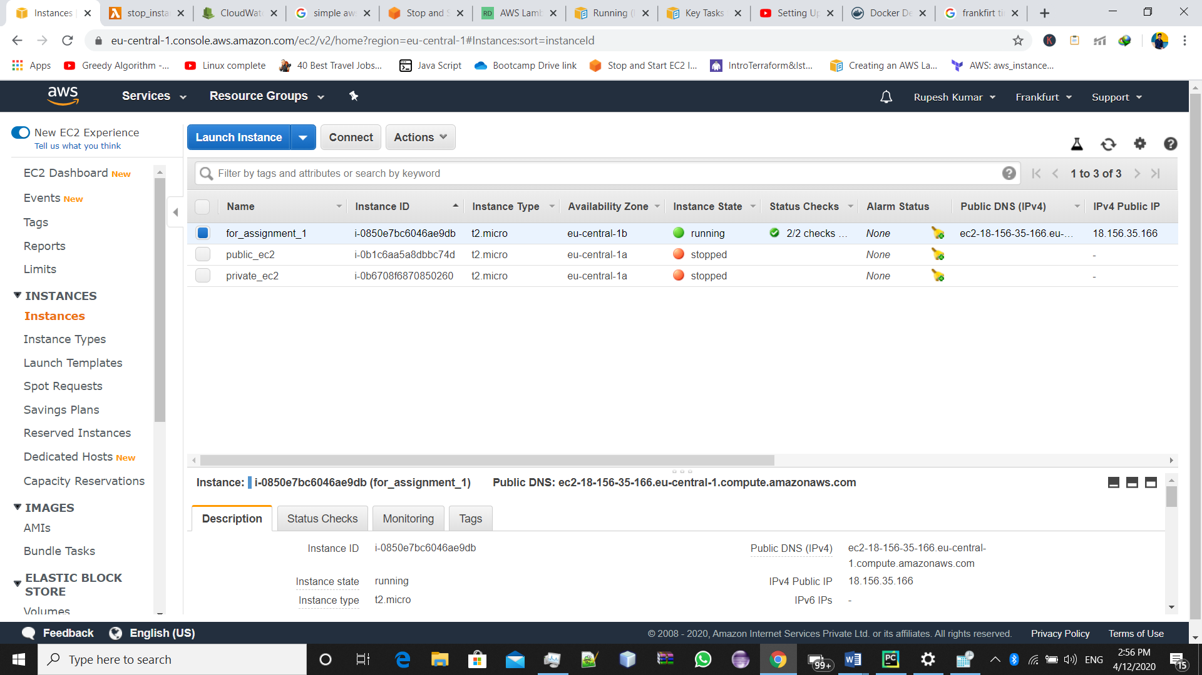

Now our instance again started running.

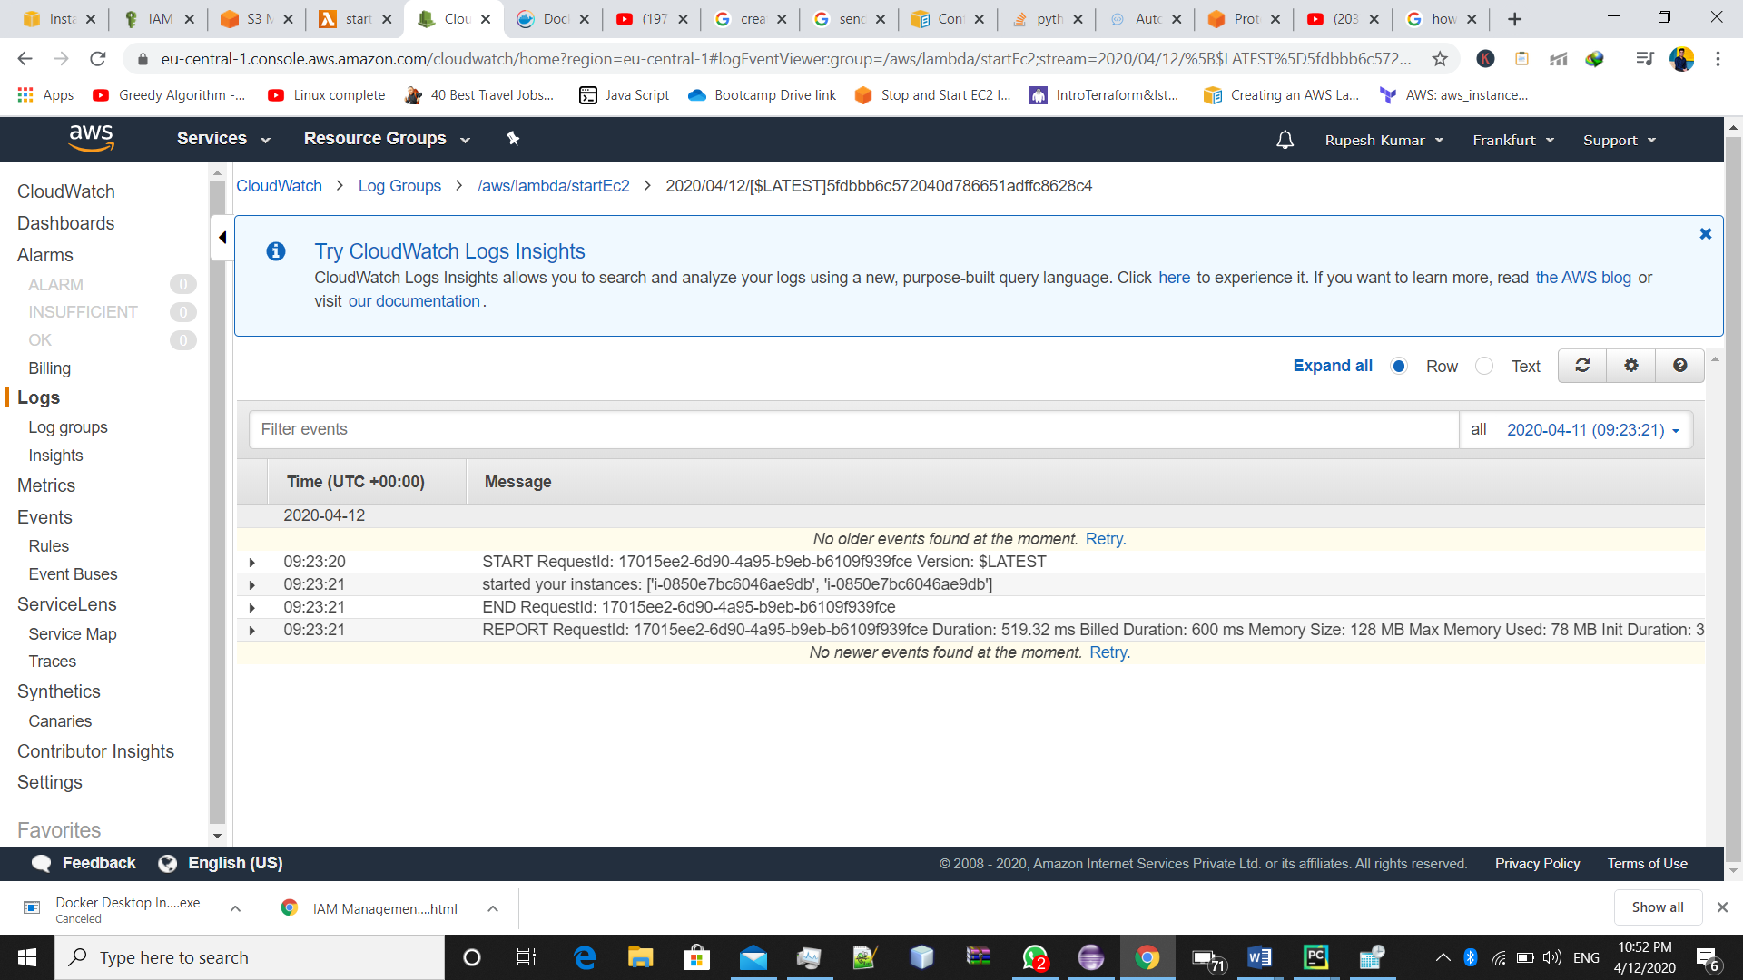

These are the logs generated for lambda from cloudWatch for startEc2 function.

#Completed.

**Asssignment : 9 Create a lambda function to send an email notification to your email id of your AWS account, as soon as you delete a file from an S3 bucket, mentioning the file name which is deleted.**

For doing so, we should a role with the following policies attached to it:

-AmazonSESFullAccess

-AWSLambdaExecute

After that we will create a lambda function which sends the email, whenever any file is deletef from a s3 bucket

We used the same approach to create lambda function(using Pycharm)

As in previous assignment.

The code for that function is this in python language:

***import*** *json****import*** *boto3****def*** *handler(event, context):* ***for*** *i* ***in*** *event[****"Records"****]:  
 action = i[****"eventName"****]  
 ip = i[****"requestParameters"****][****"sourceIPAddress"****]  
 bucket_name = i[****"s3"****][****"bucket"****][****"name"****]  
 object = i[****"s3"****][****"object"****][****"key"****]  
  
 client = boto3.client(****"ses"****)  
  
  
  
 subject = str(action) +* ***'Event from '*** *+ bucket_name  
  
 body =* ***"""  
 <br>  
 This mail is to notify you regarding {} event.  
 This object {} is deleted.  
 Source IP: {}  
   
  
 """****.format(action, object , ip,)  
  
  
 message = {****"Subject"****: {****"Data"****: subject},* ***"Body"****: {* ***"Html"****: {****"Data"****: body}}}  
  
 # send emial  
 # we need to define 3 parameters source-who will send the email , destination- to whom you want to send the email and message-your message  
  
 response = client.send_email(Source=****"rupeshkumar23091998@gmail.com"****,Destination={****"ToAddresses"****: [****"rupeshkumar23091998@gmail.com"****]}, Message=message)* ***return*** *{* ***'statusCode'****: 200,* ***'body'****: json.dumps(****'Hello from Lambda!'****)  
 }*

->now trigger event in s3 bucket and add you lambda function here

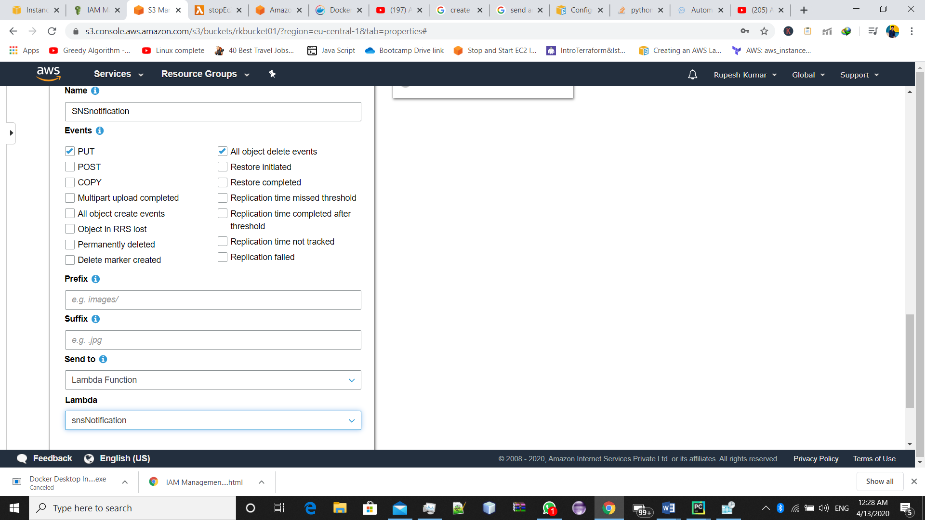

**Now whenever you delete any thing ,you will get an email for that.**

**Email ScereenShot**

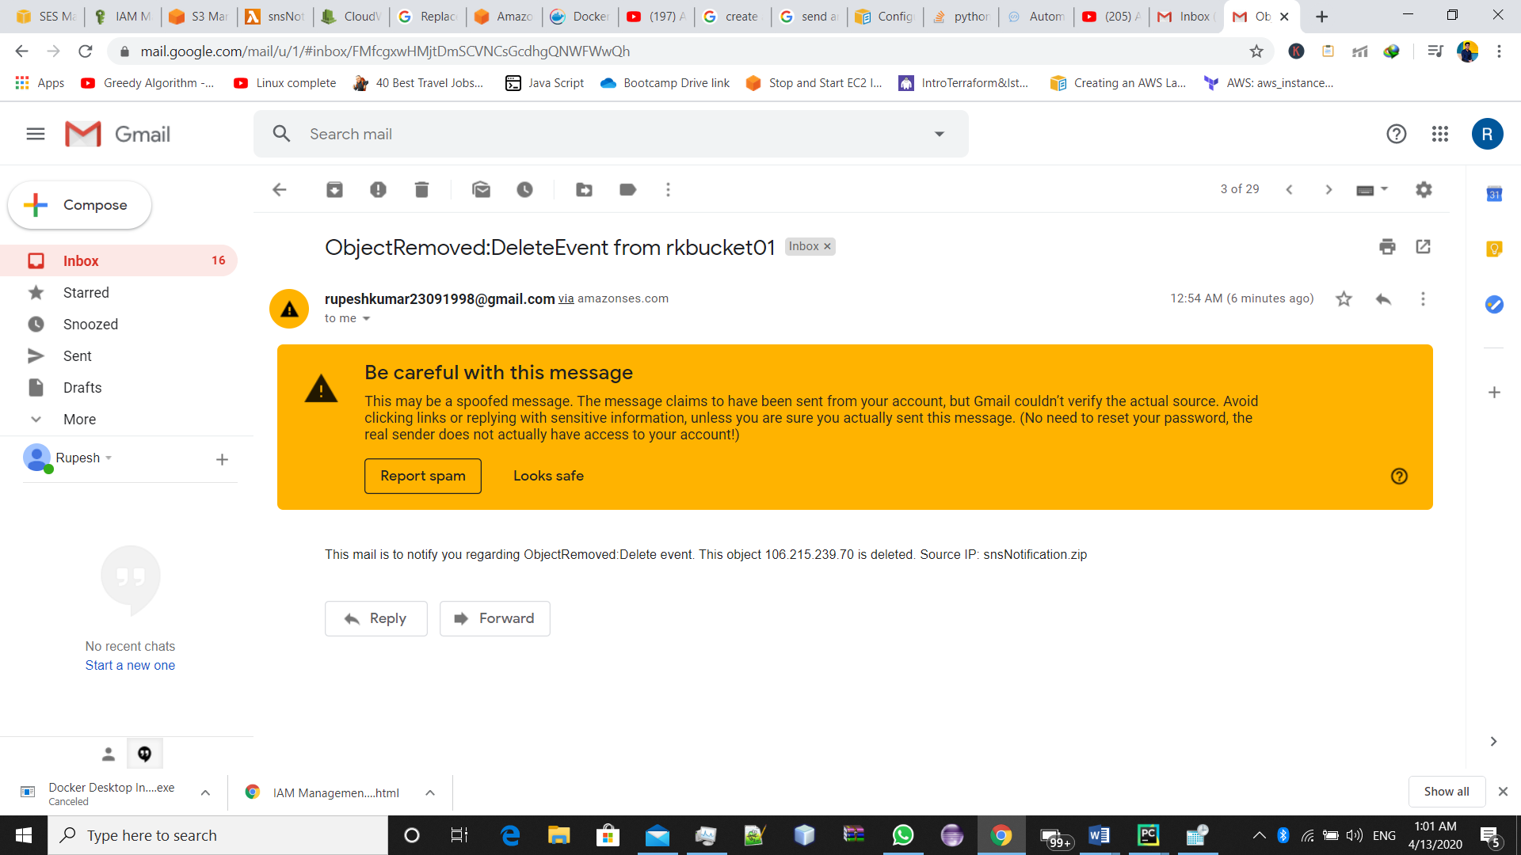

#Completed

**Assignment : 10 Whenever the EC2 instance got terminated, a snapshot should be created using Lambda, and saved in S3 bucket.**

Steps ;

First create a .py file in pyCharm and write this code which will create our snapshot.

Save this file as any desired name.

import boto3

import json

from print import print

from botocore.exceptions import ClientError

ec2client = boto3.client('ec2')

def handler(event, context):

   ec2 = boto3.resource('ec2')

   snapshot = ec2.Snapshot('i-i-0061cab91257dbbda')

   # Upload the file

   s3 = boto3.client("s3")

   s3.put_object(Bucket = "rkbucket01", Key ="snapshotec2" , Body = str(snapshot))

Now, create lambda function

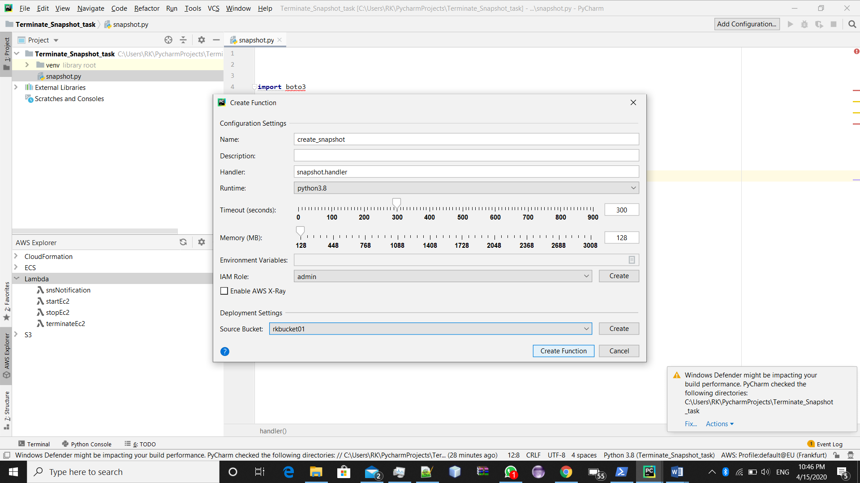

Now Open aws console and create trigger to lambda function

* 1. Create trigger event (cloudwatch event)
  2. Create new rule
  3. Rule type = Event pattern
  4. And select ec2 termination
  5. Add instance id
  6. Hit create

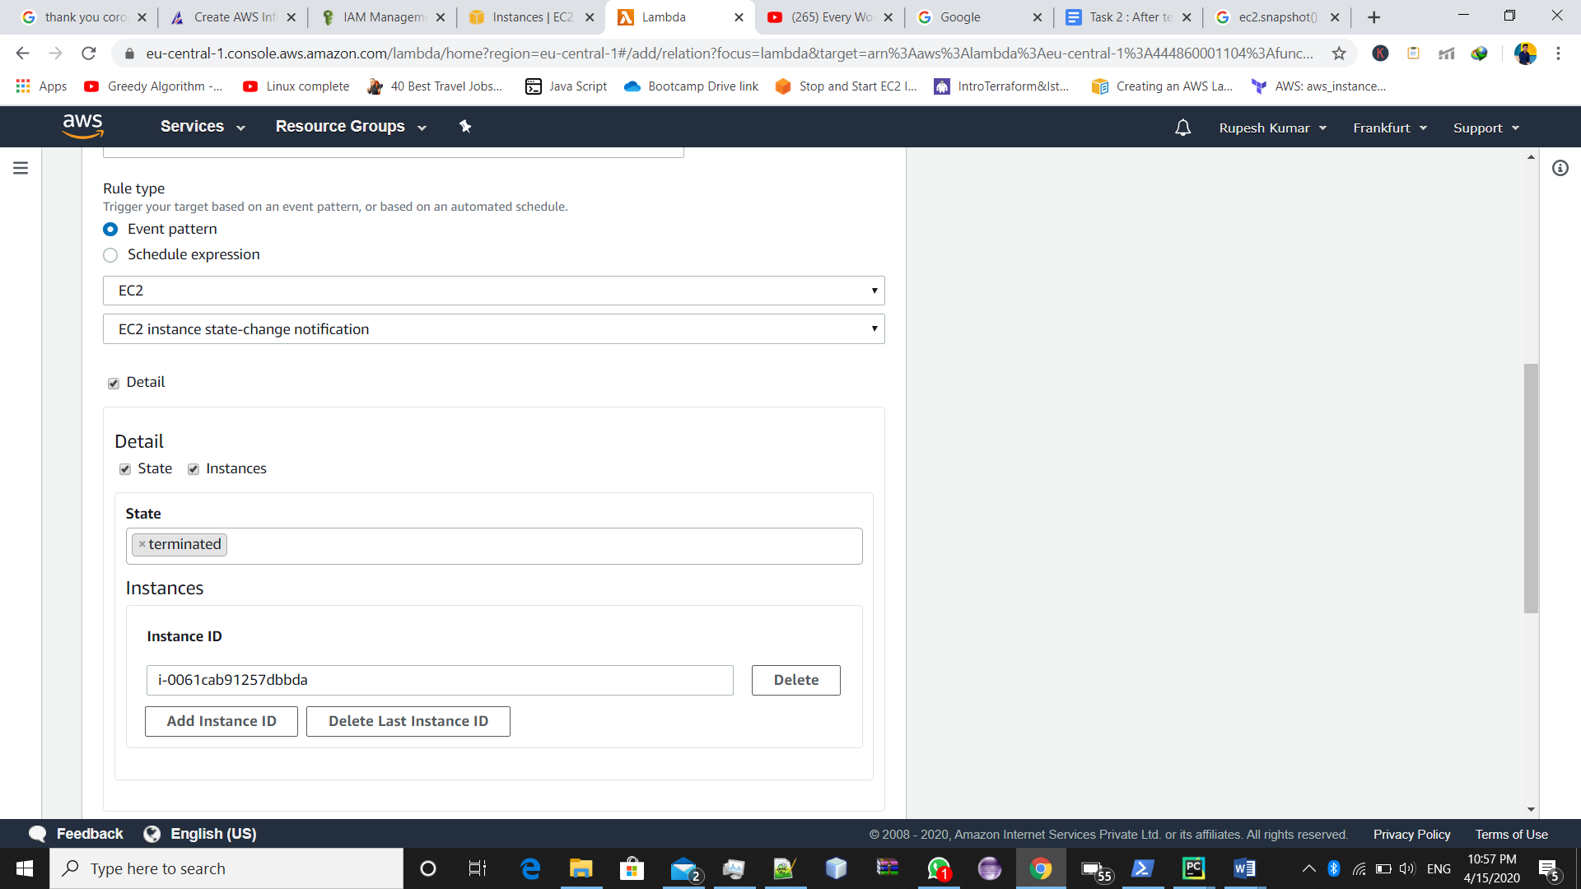

Go to ec2 dashboard and terminate ec2

And check the snapshot is present in desired s3 bucket or not

Here are some screenshot:

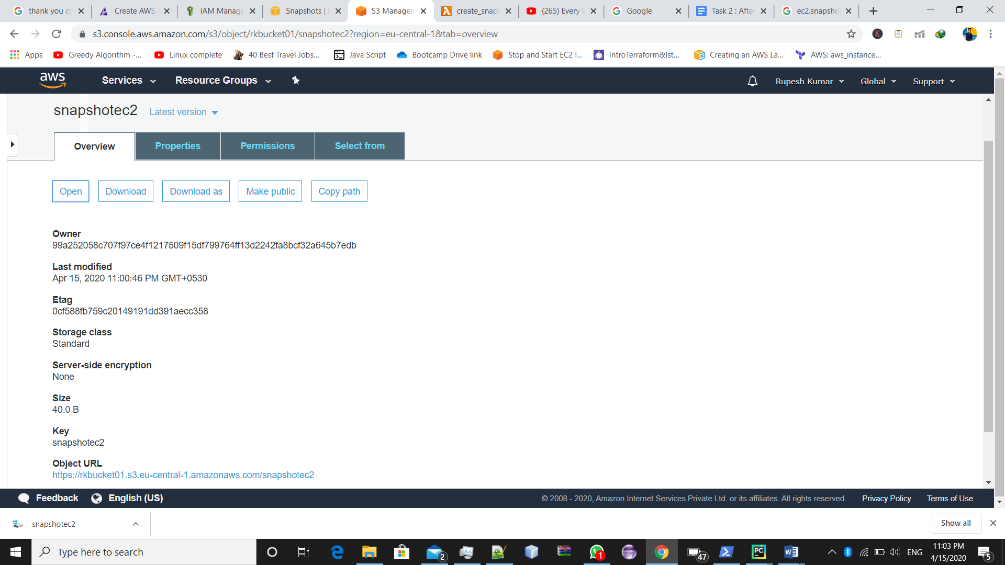

This snapshot is got saved in out desired bucker.

**#COMPLETED**